

Silver Raptor Day Cruiser
User Manual

FOREWORD

Congratulations on choosing a Silver Raptor!

This user manual will familiarize you with the features of your new boat and help you to care for and maintain it. It has been designed to help you learn how to handle your boat safely and avoid potential problems. Please check that you have received all the instruction manuals for the equipment installed on your boat when it was delivered. Add the information and instruction manuals for any equipment you purchase later to the manual. There is space for your own notes at the end of the manual. Read this manual carefully and familiarize yourself thoroughly with the details of your boat before taking it out on the water.

The user manual is not a detailed maintenance or troubleshooting guide. In case of problems, contact your boat dealer. Always use qualified and trained personnel for maintenance, repairs and modifications. Modifications that may affect the safety features of the boat must be assessed, implemented and documented by qualified personnel. The boat manufacturer is not responsible for modifications that it has not approved.

Always keep your boat in good condition and bear in mind that it requires maintenance and servicing. Any boat, regardless of its strength, can be significantly damaged if not used properly. Always adjust the speed and direction of the boat to the prevailing weather conditions.

We wish you pleasant and relaxing moments on the water with your Silver Raptor boat!

TerhiTec Oy
Sorvitie 4
63700 Ähtäri
Finland

www.silverboats.com

Keep this user manual in a safe place and pass it on to the next owner if you sell your boat.
Table of Contents

1 General 7
1.1 Declaration of conformity with the Recreational Craft Directive 2013/53/EU 8
2 Definitions 10
3 Warranty 10
4 Before use 10
4.1 Registration 10
4.2 Insurance 10
4.3 Training 11
5 Characteristics and use of your boat 12
5.1 General 12
5.2 Basic boat information 12
5.3 Maximum recommended number of passengers 14
5.4 Loading 15
5.5 Boat drainage system 15
5.5.1 Stability and buoyancy 18
5.5.2 The hull windows 18
5.6 Preventing the risk of fire or explosion 19
5.6.1 Refuelling 19
5.6.2 Other fuel-operated systems (gas stove and diesel heater) 19
5.6.3 Fire protection 21
5.7 Main switches and fuses 22
5.8 Operation 24
5.8.1 Controls 24
5.8.2 Emergency switch 25
5.8.3 Gears and throttle 26
5.8.4 Adjusting the engine trim angle 26
5.8.5 Starting the engine 27
5.8.6 Driving 28
5.8.7 Approaching and departing from the dock 28
5.8.8 Use of the canopy 29
5.8.9 Windscreen door 30
5.8.10 Stairs, sharp corners of the windscreen and cabin door 30
5.8.11 Cabin lights 30
5.9 Correct use – other recommendations and instructions 31
5.9.1 Man overboard 31
5.9.2 Storage of life raft 32
5.9.3 Securing loose equipment 32
5.9.4 Bow cabin sliding door 32
5.9.5 Respect for the environment 32
5.9.6 Use of toilets and septic tanks 33
5.9.7 Mooring and anchoring your boat 34
5.9.8 Towing 34
5.9.9 Trailer transport 35
5.9.10 Docking 36
6 Maintenance of the boat and equipment 36
6.1 Washing and waxing the boat 37
6.2 Care instructions for seat cushions 37
6.3 Care instructions for the canopy 37
6.4 Windscreen care instructions 37
6.5 Care instructions for acid-resistant parts 38
6.6 Care instructions for the electronic remote control 38
6.7 Care instructions for the steering system 38
6.8 Care instructions for electrical components 38
6.9 Minor surface repairs 38
7 Winter storage of the boat 40
7.1 Measures to be taken before winter storage 40
7.2 Measures to take before launching in the spring 40
8 Layout 42
8.1 General layout 42
8.2 Fuel system 45
8.3 Steering system 46
8.4 Electrical system 47
8.5 Wiring diagram 50

BEFORE YOU LEAVE

Read this user manual.
Always check at least the following before setting out on the water:

Weather conditions and forecast
Take into account the wind, waves and visibility. Are your boat's design class, size and equipment, as well as the skills of the skipper and crew, adequate for the waters you are going to? In strong winds and high waves, portholes, hatches and doors must be closed to prevent water from entering the boat.

Load and stability
Do not overload the boat; distribute the load correctly. Heavy items should be placed in the storage compartments under the rear bench. Also note that the stability of the boat is reduced when people are standing on it.

Passengers
Ensure that all participants have flotation devices or life jackets. Agree on each person's responsibilities during the trip before departure.

Fuel and fuel system
Check that there is sufficient fuel, including a 20% reserve in case of bad weather or other unforeseen circumstances.

Engine and steering equipment
Check the operation and condition of the steering and remote-control devices and carry out the checks specified in the engine manual.

Seaworthiness of the boat
Check the seaworthiness of the boat in other respects as well: no fuel or water leaks, safety equipment on board, etc. Check that there is no water in the boat's bilge.

Securing of goods
Check that all items are secured so that they will remain in place even in rough seas and strong winds. Note that seat cushions may fly off if their fasteners are not secured.

Nautical charts
If you are not travelling on a familiar route, make sure you have nautical charts covering a sufficiently large area! Your boat is equipped with a chart plotter, so learn how to use it before you set sail. Make sure your nautical charts are the latest edition.

Departure maneuvers
Agree with the crew who will untie which ropes, etc. Check that the mooring ropes or anchor rope do not get caught in the propeller during departure or arrival.

Mandatory equipment
According to maritime traffic legislation, every motorized watercraft must have the following equipment in working order:

1) An approved life jacket, buoyancy aid or survival suit for each person on board. The size and buoyancy of the suit must correspond to the size and weight of the person.
2) Bailing equipment
3) Oars or paddles or anchor with rope
4) Approved hand-held fire extinguisher, minimum class 8A68B. The fire extinguisher must be inspected once a year. (The boat is equipped with an approved fire extinguisher as standard. Please note as the fire extinguisher is installed in the boat during the manufacturing stage, the one-year inspection stamp may expire shortly after the new boat is put into service. According to water traffic legislation, the boat operator is responsible for ensuring that the fire extinguisher inspection stamp is valid.

Additional instructions for the engine can be found in the separate instruction manual.

- General
The user manual will help you familiarize yourself with the features, care and maintenance of your new boat. The manuals for the equipment installed on the boat are included and referred to in several places. You can, of course, supplement the manual with instruction manuals for equipment purchased later. Space is provided at the end of the manual for your own notes.

The boat has a serial number, the WIN code (Watercraft Identification Number). The WIN code is marked on the transom of the boat, below the right-hand side of the swim platform.

In some contexts, the old name CIN code (Craft Identification Number) is still used instead of the WIN code. It is the same code.

The last two digits of the WIN code indicate the model year of the boat. The third last digit indicates the year of manufacture. The boat register data always mentions the year of manufacture.

  - Declaration of conformity with the Recreational Craft Directive 2013/53/EU

Essential requirements  (referring to the numbering in Annex I to the Directive) | Harmonised standards  Full application | Harmonised standards  Partial application, see technical documents | Other technical specifications  Full application | Other technical specifications  Partial application, see technical documents | Other means of compliance  See technical documentation | Specify the harmonised standards  or other technical specifications  (including year of publication, e.g. "EN ISO 8666:2002")
 | Tick only one box per row |  |  |  |  | The rows to the right of the ticked boxes must be completed
General requirements (2)
Essential information – main dimensions |  |  |  |  |  | EN ISO 8666:2020/A11:2021
Watercraft identification number – WIN (2.1) |  |  |  |  |  | EN ISO 10087:2022
Watercraft manufacturer's plate (2.2) |  |  |  |  |  | RCD Annex I: A 2.2, EN ISO 14945:2021
Prevention of falling overboard and re-entry into the boat (2.3) |  |  |  |  |  | EN ISO 15085:2003/A2:2018
Visibility from the main steering position (2.4) |  |  |  |  |  | EN ISO 11591:2020
Owner's manual (2.5) |  |  |  |  |  | EN ISO 10240:2020
Requirements for structure, strength and tightness (3)
Structure (3.1) |  |  |  |  |  | EN ISO 12215-5:2019, EN ISO 12215-6:2018
Stability and safety (3.2) |  |  |  |  |  | EN ISO 12217-1:2017
Carrying capacity and buoyancy (3.3) |  |  |  |  |  | EN ISO 12217-1:2017
Openings in hull, deck and superstructure (3.4) |  |  |  |  |  | EN ISO 9093:2021, EN ISO 12216:2018
Water ingress (3.5) |  |  |  |  |  | EN ISO 11812:2018, EN ISO 15083:2020, EN ISO 8849:2021
Manufacturer's recommendation for maximum permissible load (3.6) |  |  |  |  |  | EN ISO 14946:2021
Storage of life rafts (3.7) |  |  |  |  |  | RSG Guidelines
Escape route (3.8) |  |  |  |  |  | EN ISO 9094:2017
Anchoring, mooring and towing (3.9) |  |  |  |  |  | EN ISO 15084:2018
Steering characteristics (4) |  |  |  |  |  | EN ISO 11592-1:2016, EN ISO 8665:2017
Engines and engine compartments (5.1)
Inboard engines (5.1.1) |  |  |  |  |  | -
Ventilation (5.1.2) |  |  |  |  |  | EN ISO 11105:2020
Unprotected parts (5.1.3) |  |  |  |  |  | -
Outboard motor start-up (5.1.4) |  |  |  |  |  | Engine declaration of conformity
Fuel system (5.2)
General information on the fuel system (5.2.1) |  |  |  |  |  | EN ISO 10088:2023, EN ISO 11105:2020, EN ISO 7840:2021
Fuel tanks (5.2.2) |  |  |  |  |  | EN ISO 21487:2018
Electrical system (5.3) |  |  |  |  |  | EN ISO 13297:2021, EN ISO 8849:2021, EN ISO 8846:2017
Control system (5.4)
General requirements for control systems (5.4.1) |  |  |  |  |  | EN ISO 10592:2022
Backup systems (5.4.2) |  |  |  |  |  | -
Gas system (5.5) |  |  |  |  |  | EN ISO 10239:2017
Fire protection (5.6)
General fire protection (5.6.1) |  |  |  |  |  | EN ISO 9094:2017
Firefighting equipment (5.6.2) |  |  |  |  |  | EN ISO 9094:2017
Navigation lights, shapes and sound signalling devices (5.7) |  |  |  |  |  | 1972 COLREG, EN ISO 16180:2018
Pollution control (5.8) |  |  |  |  |  | Engine declaration of conformity
Annex I.B – Exhaust emissions

Annex I.C – Noise emissions
Noise emission levels (I.C.1) |  |  |  |  |  | Engine conformity certificate
Owner's manual (I.C.2) |  |  |  |  |  | Engine Declaration of Conformity

- Definitions
The warnings and notes in this manual are defined as follows:

IMMEDIATE DANGER! Indicates a serious hazard that will result in death or serious injury unless proper precautions are taken.

DANGER! Indicates a potential hazard that could result in death or serious injury if proper precautions are not taken.

WARNING! Indicates a potential hazard that could result in injury if appropriate precautions are not taken.

NOTE Indicates important information related to the risk of damage to the boat, its parts or other property, but not to personal injury.

The manual uses SI units. In some cases, other units are added in brackets. An exception to this is wind speed, which is given in Beaufort in the Recreational Craft Directive.

- Warranty
The boat and its equipment are covered by a 2-year warranty, starting from the date of commission. Contact your dealer for any warranty issues. Remember to provide the WIN code. If possible, take a photo of the subject of the complaint. This usually speeds up the processing of warranty issues.

- Before use
  - Registration
In accordance with the Water Traffic Act, sailing boats and motorboats with a hull length of at least 5.5 meters, and all watercraft with an engine power of at least 15 kilowatts, i.e. more than 20 horsepower, must be registered in the Finnish boat register. More detailed instructions on registration are available from the Finnish Transport and Communications Agency Traficom. In Finland, the operator of a boat to be registered must be at least 15 years of age.

Registration regulations vary between different countries. Find out what is required in relation to your own boat if used outside Finland.

  - Insurance
Boat insurance can cover damage that occurs on the water or during transport and docking. Make sure you have insurance coverage when lifting the boat. Insurance also has an indirect effect on safety on the water: in the event of a serious accident, you can focus on rescuing people first and foremost. Insurance companies can provide more detailed information on the various insurance options. Make sure you have insurance coverage when lifting and transporting your boat!

  - Training
There is a wealth of literature on boating. Navigation courses are organized by the Finnish Navigation Association (www.suomennavigaatioliitto) in cooperation with adult education centers.

Information on boating schools is available from: Finnish Sailing and Boating (www.spv.fi). These provide a good foundation for your skills, but confidence in handling, navigating, mooring and anchoring a boat can only be achieved after long practical training.
- Characteristics and use of your boat

5.1 General
The purpose of this user manual is not to be a complete maintenance guide or repair manual, but to instruct the user on how to use their boat properly.

5.2 Basic boat information
The basic information about the Silver Raptor DC boat is as follows:

Manufacturer/manufacturer's representative:
Fenix Marin Oy, Mahliankatu 5, 37600 Valkeakoski

Type: Silver Raptor DC

Design class: C
The design class refers to the following:

Design category A: The boat is designed for use in conditions where the wind force is less than 10 Beaufort (approx. 25 m/s) and the significant wave height is commensurate. The conditions described are typically encountered on long voyages, such as ocean crossings, or on the coast when the voyage is exposed to wind and waves for several hundred nautical miles. Depending on atmospheric conditions, gusts can reach approx. 32 m/s.

Design category B: The boat is designed for use in conditions where the wind force is up to 8 Beaufort (approx. 21 m/s) and the waves are correspondingly high (significant wave height up to 4 m, see Note below). Such conditions are typically encountered on sufficiently long open sea voyages or in coastal waters when the voyage is exposed to wind and waves for several tens of nautical miles. The conditions described may also be encountered on lakes that are large enough for the wave height in question to develop. Depending on atmospheric conditions, gusts may reach approx. 27 m/s.

Design category C: The boat is designed for use in conditions where the steady wind speed is no more than 6 Beaufort (approx. 14 m/s) and the waves are correspondingly small (significant wave height no more than 2 m, see Note below). Such conditions are typically encountered on open lakes, river estuaries and coastal waters in moderate weather conditions. Depending on atmospheric conditions, gusts may reach approx. 18 m/s.

Design category D: The boat is designed for use in conditions where the wind force is up to 4 Beaufort (approx. 8 m/s) and the waves are correspondingly high (significant wave height up to 0.3 m, occasional maximum waves 0.5 m high). Such conditions are typically encountered on sheltered inland waters and in coastal waters in good weather. Depending on atmospheric conditions, gusts may reach approx. 12 m/s.

Note: Significant wave height is the average height of the highest third of the waves, which roughly corresponds to the wave height estimated by an experienced observer. Some individual waves may be approximately twice as high.

Maximum recommended load: See technical specifications. Table 1.
See also section 5.4 "Loading".

Main dimensions and capacities: See technical specifications. Table 1.

The length, width, draught, total weight, etc. of the boat, as well as tank capacities, are specified in the technical specifications.

Manufacturer's plate:
Part of the above information is provided on the manufacturer's plate (Figure 1) which is attached to the boat next to the steering position. Additional information is provided in the relevant sections of this manual.

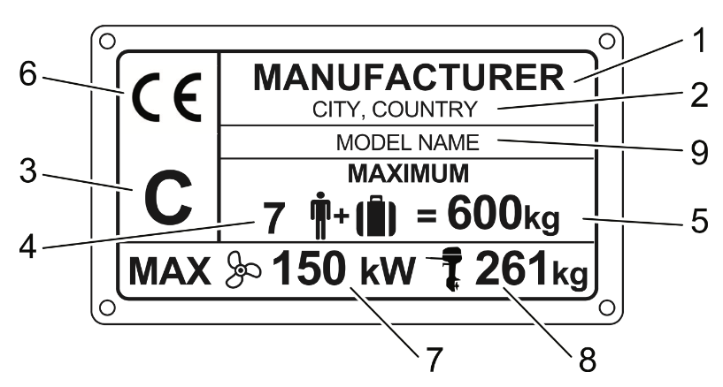
Figure 1. Information provided on the manufacturer's plate:
1. manufacturer's name, 2. manufacturer's/manufacturer's representative's contact details and, where applicable, the identification number of the notified body, 3. boat design category, 4. maximum number of persons, 5. maximum recommended load (kg), 6. CE marking, 7. Maximum power of outboard motor(s) [kW], 8. Maximum weight of outboard motor(s) [kg], 9. Boat model.

Table 1: Technical specifications
Model |  | SILVER RAPTOR DC
Design category |  | C
Overall length (excluding swim ladder) |  | 8.05 m
Width |  | 2.76 m
Weight without engine, fluids and equipment |  | Approximately 1980 kg
Weight when transported on a trailer with the standard maximum engine |  | Approximately 2,800 kg  Includes boat (approx. 1,980 kg) and 350 hp engine (375 kg) as well as estimated weight of fluids and equipment (340 kg). NOTE This is not the maximum weight of fluids and equipment.
Maximum load/maximum number of persons |  | 1070 kg  10 persons
Maximum load includes |  | 750 kg / 10 persons (75 kg each) + personal equipment 50 kg + fuel 195 kg + fresh water 45 kg + wastewater 30 kg
Maximum load on CE plate |  | 800 kg  Includes 10 x 75 kg = 750 kg + personal equipment 50 kg = total 800 kg
Boat weight at full load |  | Approximately 3,700 kg  Includes boat 1,980 kg + engine 375 kg + batteries 40 kg + basic equipment 80 kg + personal equipment 50 kg + fuel 195 kg + water 45 kg + septic tank 30 kg + life raft 30 kg + persons 750 kg
Maximum engine power |  | 258 kW / 350 hp
Maximum engine weight |  | 375 kg
Liquid tank capacity |  | Fuel tank 260 liters, septic tank 30 liters,  Water tank 43 liters
Maximum draught with full load, engine up |  | 0.5 m
Maximum height above waterline with light load  Height from keel to top of windscreen |  | 1.7  2.25
Construction material |  | Reinforced plastic
Colour code (frame and cover) |  | RAL 9016
Hydraulic hoses |  | 2 x 2.6 m  2 x 3.6 m
Top speed achieved in boat test |  | Approximately 46 knots

5.3 Maximum recommended number of passengers

The maximum recommended number of passengers on board is 10. Seating positions are shown in Figure 2.

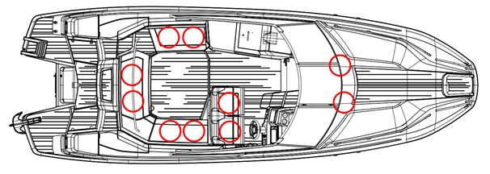

Figure 2.
 Seating positions

WARNING! Do not exceed the maximum number of people recommended. Regardless of the number of people on board, the total weight of persons and equipment must never exceed the maximum recommended load (see section 5.4 "Load"). Always use the seats or seating positions provided in the boat. While the boat is in motion, all persons on board must be seated.

  - Loading
The maximum permissible load for the boat is 1070 kg. This includes the following weights:
- total weight of persons on board 750 kg (assumed weight of one adult 75 kg, child 37.5 kg)
- the weight of liquids in fixed tanks (fresh water, wastewater, fuel, etc.) is 240 kg
- weight of personal equipment (e.g. recreational equipment and overnight gear) 50 kg
- weight of other cargo (septic tank full) 30 kg.

NOTE! The maximum load only includes the weight components mentioned above.

WARNING! When loading the boat, never exceed the maximum recommended load. Always load the boat carefully and distribute the load appropriately so that the boat floats straight. Heavy items should normally be placed in the storage space under the rear seat. If the boat is carrying the maximum number of passengers, heavy items should be placed in the front cabin to prevent the boat from becoming rear-heavy. Avoid placing heavy items high up.

  - Boat drainage system
The boat has a rainwater drainage system, which means that rainwater is drained from the open space when the boat is in the water. The rainwater drainage system also works on land, if the bow is higher than the stern and the rainwater drainage valve is open. The rainwater drainage valve is located under the maintenance hatch below the centre hatch of the rear seat. The valve is only intended to be closed when carrying the maximum permissible load to prevent water from entering the boat. In other cases, the valve must always be open to allow rainwater to drain from the boat.

NOTE! The open space in the boat should be protected from rain with either a driving canopy or a harbour cover. Although the cushions in the open area are made of water-resistant material, water can seep through the seams, causing the foam inside the cushion to absorb water. The control console panels, switches and power outlets are also not waterproof.

An electric bilge pump is installed in the boat between the fuel tank and the transom. The capacity of the electric bilge pump is approx. 45 l/min.
The bilge pump can be accessed through a hatch in the engine compartment. NOTE! If you open the hatch, remember to close it carefully, because the hatch can go under water if the boat is heavy loaded.

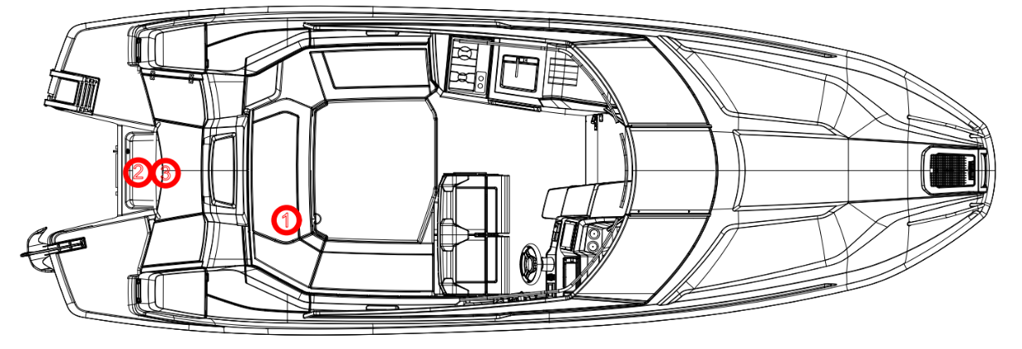

Figure 3.
1. Open space drainage shut-off valve
2. Electric/automatic bilge pump
3. Shut-off valves for emptying the engine well

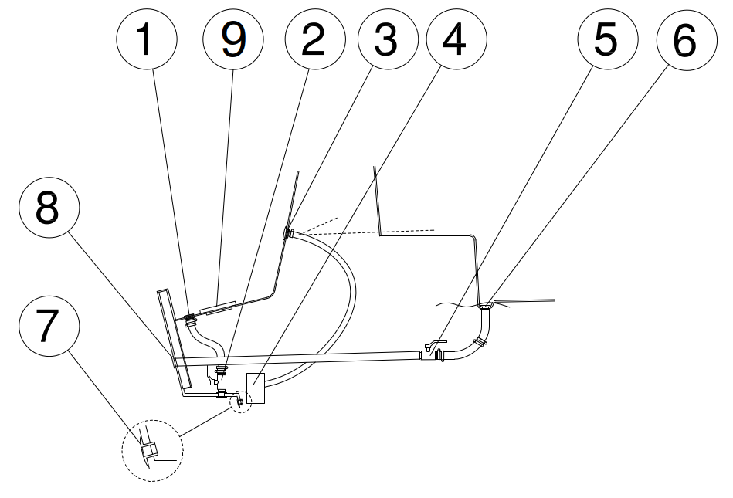
Figure 4: Boat drainage system

1. Engine compartment drainage outlets (2 pcs) 5. Open space drainage shut-off valve
2. Engine compartment drainage shut-off valves 6. Open space drainage outlet
3. Bilge pump drain 7. Bilge space drain plug
4. Electric/automatic bilge pump 8. Non-return valve

It is the boat owner's responsibility to keep a hand pump, bucket or at least a bailer on board.

NOTE! A small amount of condensation always accumulates in the bilge. The fittings may also allow a small amount of water to pass through, especially as the boat ages. Always check the bilge before leaving the boat at the dock or buoy and before setting out on the water. Have any leaks repaired by an authorised service centre.

WARNING! The bilge pump system is not designed to control leaks caused by hull damage resulting from grounding or other damage.

NOTE! Check regularly that there is no debris at the end of the bilge pump suction hose. You can check the electric bilge pump by removing the service hatch in the engine compartment.

WARNING! The maintenance hatch at the bottom of the engine compartment must be closed carefully so that it screws into place properly, and the hatch must also be tightened securely. A carelessly closed hatch can lead to serious leakage.

WARNING! Always close the drain pipe when its inner end is constantly below the waterline due to the load. The shut-off valve in the transom prevents water from entering only when reversing!

NOTE! Ensure that water can flow freely out of the drain pipe. Any debris, such as leaves in autumn, can prevent water from flowing, causing the boat to fill with water and sink. The drainage system does not work in freezing conditions.

WARNING! The boat's handling characteristics may become life-threatening if there is water in the boat's intermediate floor.

    - Stability and buoyancy
Please note that the stability of the boat is reduced by any additional weight added to the top of the boat. Any changes in the distribution of weight can significantly affect the stability, handling and performance of the boat. However, please remember that large breaking waves always pose a serious threat to stability.

    - The hull windows

The hull windows of the boat must be kept closed while the boat is in motion. Also close the hull windows when leaving your boat at a jetty or buoy. In rough weather, hatches, lockers and doors must be kept closed to minimise the risk of flooding.

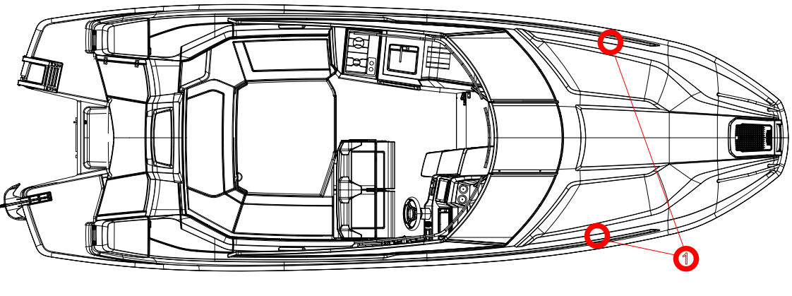

Figure 5. Hull windows must be kept closed while the boat is in motion. 

  - Preventing the risk of fire or explosion
    - Refuelling
Before refuelling, switch off the engine, gas stove and, of course, cigarettes. During refuelling, do not use any devices that may cause sparks.

If the nozzle kicks back while refuelling, you must turn the nozzle at least 20 degrees so that the spray does not hit the chain mounting screw directly.

Hint: If you are afraid that petrol will splash onto the synthetic teak deck while refuelling, it is a good idea to wet it with water before refuelling. You can also place a cloth over the filler neck to prevent petrol from splashing onto the deck.

Always carry spare fuel with you. Store spare fuel cans in the rear anchor boxes, not in the rear seat storage compartments (for fire safety reasons).

Do not store loose items under the rear seat that could block the fuel supply to the engine when moving. Check the fuel lines annually, especially at the feed-through points, for wear.

Please note that the full capacity of the tanks may not always be available, depending on the trim or heel angle of the boat.

WARNING! Vapourised fuel is highly explosive. Exercise extreme caution and follow these instructions when refuelling. The smell of fuel always indicates that there is vapourised fuel in your boat.

    - Other fuel-operated systems (gas stove and diesel heater)
The gas stove and diesel heater (optional) have separate operating instructions and are therefore not described in detail in this user manual. The heater's fuel tank is in the storage compartment on the left side of the rear seat (under the plywood panel). When refuelling the diesel tank, switch off the heater. Do not use switches or devices that may cause sparks when handling gas or diesel. Clean up any spilled fuel immediately.

Light the gas stove with a match or cigarette lighter.

NOTE! Only use liquefied petroleum gas, which is propane or a mixture of propane and butane, in gas stoves.

NOTE Always keep the gas compartment door closed. The gas compartment is ventilated to the outside air through the side of the boat. A possible gas leak does not pose a danger to those on board when the gas compartment door is properly closed.

NOTE Always close the gas cylinder valve when leaving the boat.

NOTE When cooking, use potholders if there is even the slightest risk that the boat may be exposed to waves.

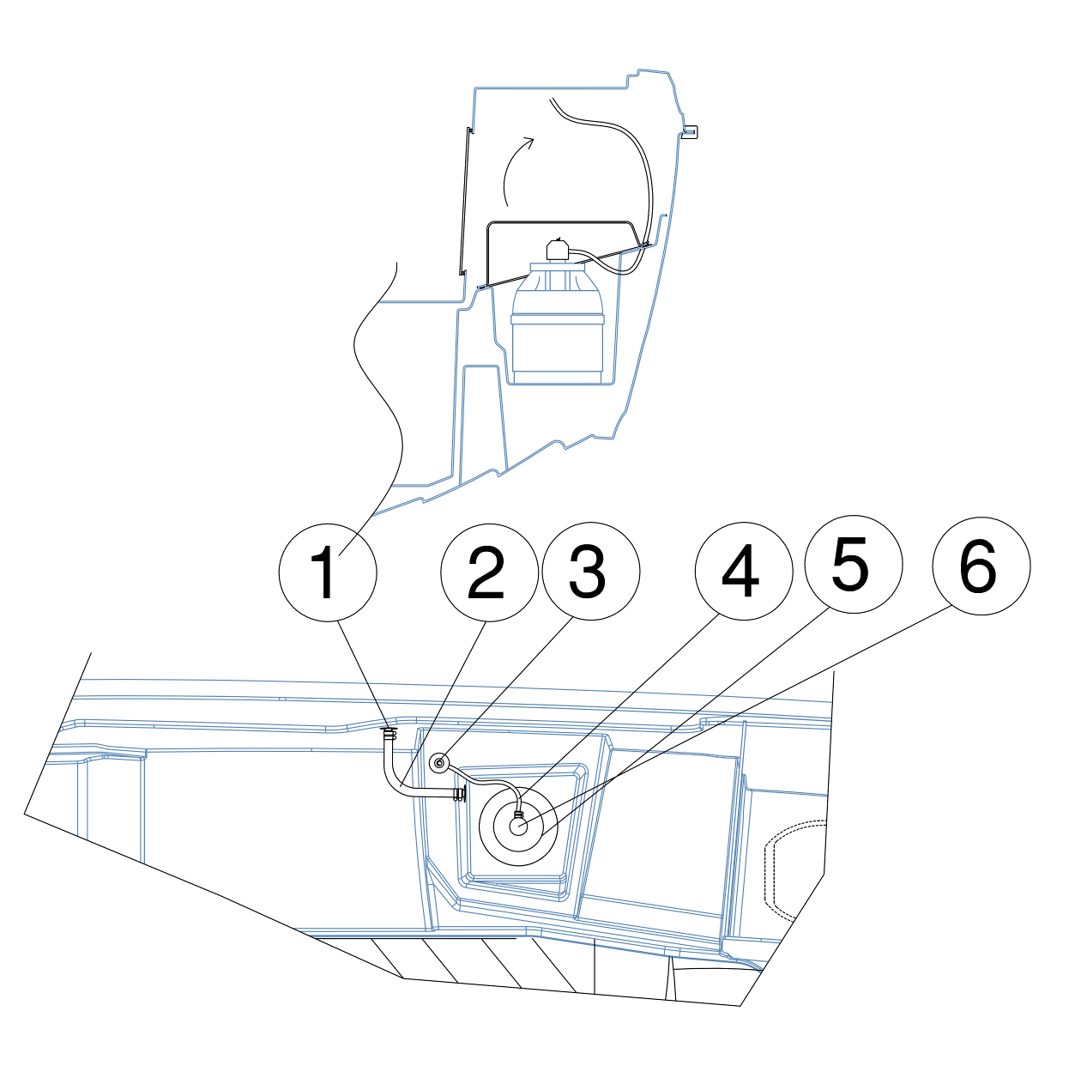
Figure 6. Gas stove

1. Hull penetration 4. Gas hose
2. Gas tank ventilation hose 5. Gas cylinder (5 kg composite, optional)
3. Gas hose connector to the stove 6. Low pressure regulator

NOTE! When lowering the stove cover, there must be nothing on the stove that could get caught. When the boat is moving, the gas stove cover must be lowered, and the sink cover must be in place.

NOTE If you use potholders, remove them before closing the stove cover.

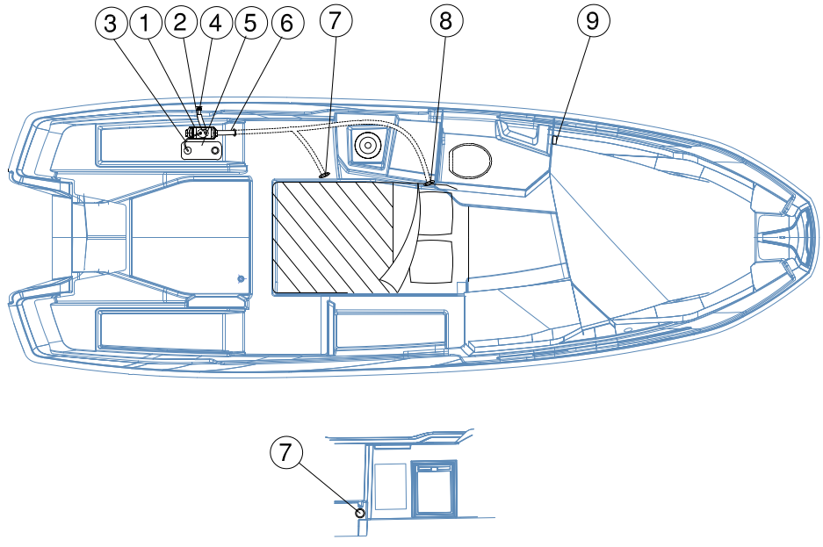

Figure 7. Heating system (optional)

1. Heater 6. Air hose
2. Exhaust pipe 7. Air vent to open space
3. Fuel hose 8. Air vent to cabin
4. Exhaust pipe feed-through 9. Control switch / temperature regulator
5. Fuel tank

NOTE If a heater (optional extra) is installed in the boat, do not block the air vents when the heater is on, as this will cause the heater to overheat and the overheating protection may be activated.

    - Fire protection
The boat is equipped with a 2 kg hand-held fire extinguisher, class 13A 89B C. To ensure that the extinguisher is in working order, it must be inspected once a year by an authorised inspector. If the hand-held fire extinguishers are replaced, they must be replaced with hand-held fire extinguishers with at least the same extinguishing capacity as the old ones.

Ensure that fire extinguishing equipment is easily accessible even when the boat is loaded. Inform all crew members of the location and operation of firefighting equipment. The fire extinguisher is located in the storage compartment of the right-hand seat in the open space, immediately behind the driver's seat.

Location of the hand-held fire extinguisher

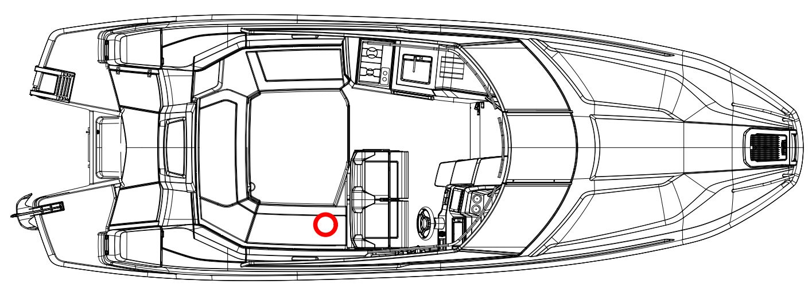
Figure 8.
Hand-held fire extinguisher

Never

- block access to safety equipment, such as electrical system switches
- block access to hand-held fire extinguishers stored in storage compartments
- leave the boat unattended when the stove is in use
- modify any of the boat's systems (especially the electrical or fuel systems) or allow an unqualified person to make modifications to any of the boat's systems
- fill any fuel tanks while the equipment is in use
- smoking when handling fuel or gas.

  - Main switches and fuses
Main switch operation:

- The switch shows a green colour -> circuit connected (in the picture, the power is turned on)
- Switch shows red colour -> circuit disconnected

Turn off both main switches when leaving the boat and always turn both on when using the boat.

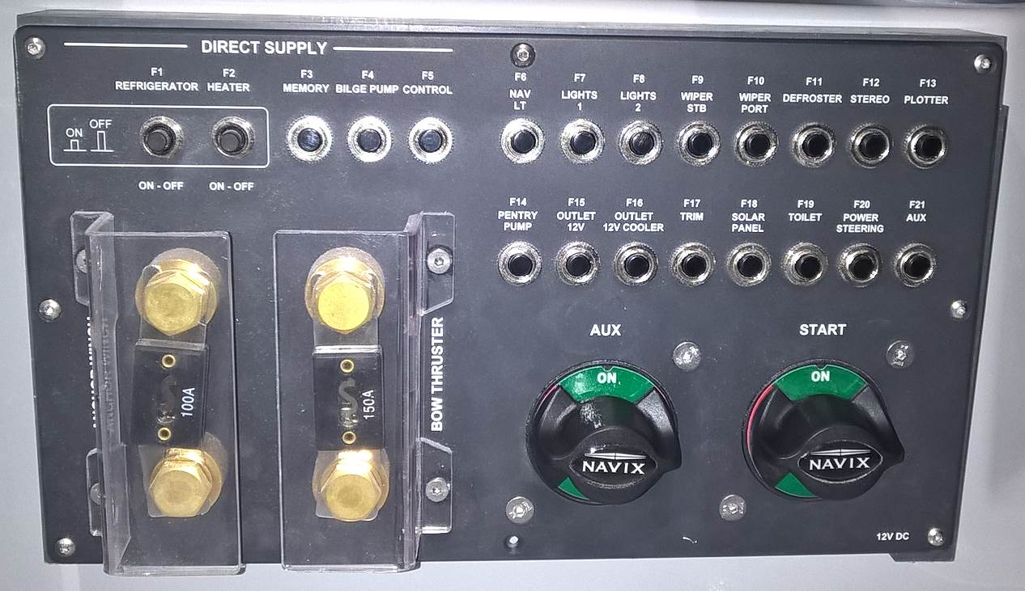
7.
6.
3.
1
2.
5.
4.

Figure 9. Main switches and fuses

1. Main power switch 5. Rear anchor winch (optional) fuse
2. Main switch for operating current 6. Direct feed switch for refrigerator*
3. Fuse panel 7. Heater (optional) direct power supply switch
4. Bow thruster fuse switch*
*Switched on when the button is pressed.

Do not switch off the direct supply if you want the refrigerator or heater to continue operating during your absence. The refrigerator (Refrigerator F1) is number 6 and the heater (Heater F2) is number 7.

The circuit breakers are located above the main switches. The sizes of the circuit breakers are also shown in the electrical diagram. Do not change the amperage ratings of the circuit breakers or install components in the electrical system that exceed the rated amperage of the circuit.

All fuses (except for the bow thruster and anchor winch) are automatic fuses. In the event of a fault current, the automatic fuse trips and remains off. You can "reset" the fuse by pressing it back in. If the fuse trips again, there is a short circuit in the electrical system or in one of the components. Repairs to the boat's electrical system must be carried out by a qualified electrician.

NOTE! Also switch off the power when performing electrical installations.

NOTE Never turn off the power at the main switch while the engine is running! This may damage the engine's electrical system.

NOTE! Do not carry out electrical installations while the power is on. Have larger electrical installations carried out by a professional.

WARNING! When disconnecting or connecting batteries, be careful not to touch both terminals of the battery with a metal object at the same time.

  - Operation
    - Controls
Controlling the boat is easy to learn but changing conditions such as wind and waves constantly present the driver with new situations. The remote-control device combines throttle, forward and reverse gears, and engine trim angle adjustment. The boat is equipped with hydraulic steering.

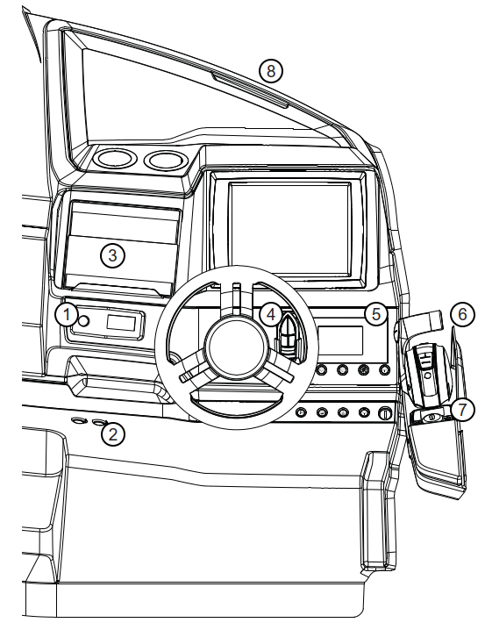
Figure 10. Controls

1. Radio
2. 12 V – standard and USB
3. Tablet holder / glove compartment / inside the hatch is the hydraulic steering oil filler
4. Remote control for bow thruster and stern anchor winch (optional)
5. Outboard motor gauges/devices
6. Remote control for outboard motor
7. Mente Marine automatic trim system control panel
8. Defrosting nozzle

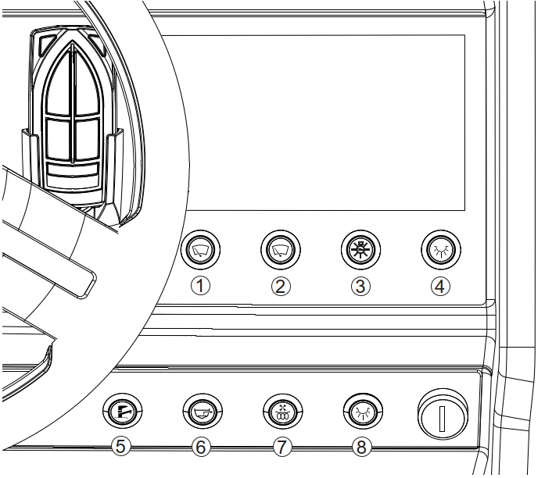

.

.
Figure 11. Control console buttons

1. Windscreen wiper BB 5. Fresh water pump
2. Windscreen wiper SB 6. Bilge pump
3. Navigation lights 7. Windscreen defroster
4. Deck lights 8. Search light/ bow light

    - Emergency switch
A safety switch is a device with one end attached to a switch located under the remote-control unit and the other end attached to, for example, a life jacket. The safety switch automatically shuts down the engine when it is disconnected from the switch on the remote-control unit. It is extremely important that the boat stops if, for some reason, the operator loses their balance and is thrown from the helm.

NOTE! Never operate the boat without attaching the safety switch to yourself. If you attach the safety switch to your arm, do not steer the boat with that hand, as the chain may get caught in the steering wheel during sharp turns.

NOTE! The engine will not start unless the safety switch is attached to the switch on the remote control.

DANGER! A rotating propeller is life-threatening to anyone who has fallen into the water or is swimming. Use the emergency stop switch and turn off the engine whenever a swimmer or water skier gets into the boat.
    - Gears and throttle
You can engage the gear by pressing the button on the gear/throttle lever with your fingers pointing upwards and pushing or pulling the gear/throttle lever forwards or backwards, depending on which direction you want to move in. Once the gear is engaged, you can adjust the speed of the boat using the same gear/throttle lever.
When the boat is moving slowly forward, reverse can be used as a brake, for example when approaching a jetty. Reverse gear must not be engaged when the boat is moving slowly forward. This will damage the engine.

    - Adjusting the engine trim angle
The basic rules for adjusting the engine trim angle are as follows:

- When lifting the boat into a glide, keep the bow down.
- When the boat is gliding and the waves are small, raise the bow until the engine and boat are running smoothly. If the engine is trimmed too high, the boat's speed will decrease. If you drive with too little trim, the boat will move slowly, and the engine will run heavily. To achieve good fuel economy, it is important to drive with the correct engine trim (= correct trim angle).
- In heavy head seas, lower the bow to soften the ride.
- In following waves, raise the bow so that it does not "dive" into the waves.

WARNING! Do not drive the boat at high speeds with the engine trimmed up
(= bow up) as there is a risk that the boat will tilt sharply when the propeller hits the water after flying through the air in heavy waves. Similarly, do not drive at high speeds with the engine trimmed completely negative (= bow down), as this may cause the boat to tilt unexpectedly when the bow hits the water. If the bow is too low, instability may occur when turning.

The boat is equipped with Mente Marine - automatic trim system. Using the trims manually while driving, especially in rough weather, adds unnecessary challenges to driving. The trim levels are used to adjust the boat's position according to the conditions. The correct position keeps engine consumption as low as possible.

The system can also be used in the same way as manual trims to find the desired running position for the boat. Once the correct position has been found, it can be locked into memory, and the automatic system takes care of the rest.

Pressing the Auto button (Figure 12) activates the trim tabs automatically.

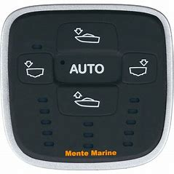

Figure 12: Mente marine - control panel buttons

The Mente Marine automatic trim system does not control the outboard motor trim. The outboard motor trim should be used in the same way as on a boat without an automatic trim system.

WARNING! If you are using the trims manually, adjust the trim controls carefully at high speeds. They will change the boat's handling dramatically.

WARNING! Waves reduce the boat's manoeuvrability and cause it to tilt. Take this into account by reducing speed as the waves increase.

    - Starting the engine
- Turn on the power using the main power switch. Always turn on both the engine battery (Start) and the auxiliary switch (Aux).
- Lower the engine to the running position by pressing the Trim switch on the gear/throttle lever down with your thumb.
- Check that the gear/throttle handle is in the neutral position and that the safety switch is connected to the remote-control switch.
- Turn on the power without starting the engine and wait a few seconds for the warning lights to come on.
- Start the engine by turning the ignition key clockwise until it starts. The engine should start within 1-2 seconds. If the engine does not start, do not continue starting for more than 10 seconds at a time.
- Once the engine has started, let it idle for a few minutes before driving off. (See the engine manual!)

More detailed operating instructions can be found in the engine manual.

    - Driving
Driving in fair and calm weather is easy. However, remember that adequate visibility is essential. To ensure the best possible visibility from the driver's seat:

- position passengers so that your field of vision is not restricted
- do not drive near planing speed for long periods, as the bow will rise and obstruct your view
- in poor visibility, look over the windscreen
- especially on shipping lanes, remember to also look behind you

Use your navigation lights when it gets dark.

Always adjust your speed to the prevailing conditions and the environment. Take following into account:

- waves (also ask passengers for their opinion on a comfortable speed)
- your own wake (largest when planing, smallest at displacement speed, i.e. less than 5 knots)
- visibility (islands, fog, rain, glare from the sun)
- knowledge of the route (time needed for navigation)
- narrowness of the route (other watercraft, noise and wake waves on the shores)
- make sure you always have enough distance to avoid a collision, which is sufficient to stop or swerve.

When travelling slowly, a planing boat has poorer directional stability than at higher speeds
speed. Therefore, be careful in narrow areas and especially when encountering other boats.

The boat's running position has a significant impact on handling characteristics, as well as
fuel consumption and visibility from the helm. You can affect the running position by

- placing the load properly. The general rule is to keep as little weight as possible in the bow.
- adjusting the engine trim angle

The correct trim position combined with the appropriate speed also makes driving in waves
more comfortable and safer.

WARNING! High speed and sudden steering manoeuvres in high waves can cause you to lose control of the boat, high tilt angles, and result in serious injury or death.

NOTE! The boat is not designed to be bounced on waves in such a way that it completely leaves the water. The warranty does not cover damage caused by airborne flight. Possible airborne flights can be checked from the engine history using a computer.

    - Approaching and departing from the dock
Practise handling the boat when approaching the dock in a place where there is plenty of space before driving your boat into a narrow harbour for the first time.

Very cautious throttling does not provide the necessary steering power. Effective steering manoeuvres when approaching the dock are achieved by using the throttle firmly but in short bursts.

Ensure that all persons on board who are not required to stand remain seated while you are manoeuvring the boat towards the dock. Sudden steering movements can cause the boat to tilt and result in injuries.

Before approaching the dock, prepare the mooring lines at the bow and stern. Approach the dock at a slight angle with the bow first. Just before touching the dock, turn the steering wheel towards the dock and shift into reverse. Accelerate briefly and sharply. The boat will stop and turn parallel to the dock. If possible, approach the dock into the wind or against the current, whichever is stronger. This makes it easy to continue your journey when the wind or current pushes the boat away from the dock. The best way to pull away is to first push the stern as far away from the dock as possible. Then slowly reverse away from the dock into open water.

The propeller is designed to provide the best traction when moving forward. When reversing, the propeller's power is therefore weaker. The boat also does not respond to steering as well when reversing as when moving forward.

WARNING! The boat is fast. It will not stop immediately when you apply the brakes. Slow down in good time before approaching the shore or a jetty. Learn to estimate the distance required to stop the boat. Remember that the boat is difficult to steer when the engine is not running.

WARNING! Do not try to stop the boat by hand, and do not put your hands or feet between the boat and the jetty, shore or another boat! Practise landing in good conditions! Use engine power moderately but decisively!

NOTE When mooring your boat, consider changes in wind direction, rising or falling water levels, stern waves, etc. Further instructions are available from insurance companies, for example.

    - Use of the canopy
The canopy is designed to withstand speeds of up to 30 knots on the water and 50 km/h on the road when on a trailer. The canopy must be securely fastened during transport. The canopy is designed so that it is possible to keep only the front part of the cover up. To make it easier to fit the canopy into the cover box, we recommend that you remove the sides and rear of the canopy. Then fold the upper parts of the sides completely over the roof so that there is no fabric left at the corners of the canopy arches. Finally, carefully roll up the roof section and the folded side sections and place the canopy in the canopy box.

NOTE! The boat should not be used in the rain without a canopy. The equipment in the open area of the boat is not waterproof and must be protected from rain.

NOTE! The windscreen and canopy structure may not be completely watertight. When the canopy is on, water may enter the boat between the canopy and the windscreen.

    - Windscreen door
The windscreen door must always be kept closed and locked when the boat is in motion.
The door is not designed to be used as a handrail when entering or exiting the boat.

WARNING! When sailing, in strong winds or gusts, the door must be kept closed, as there is a risk that the door may slam shut. The door is heavy and may cause personal injury if it hits a person when it slams shut.

WARNING! When the boat is stationary, large waves or gusts of wind may cause the door to slam shut unexpectedly. For this reason, it is recommended that the door be kept always closed when not travelling via the foredeck.

    - Stairs, sharp corners of the windscreen and cabin door
Great care should be taken on the stairs, especially if the cabin door is open.

NOTE! When driving the boat, lock the cabin door with the locking latch, otherwise the door may close at high speed.

WARNING! Be careful of the upper corner of the left windscreen when climbing the stairs, so that your head does not hit the sharp corner.

The front anchor box hatch is equipped with a rubber band that keeps the hatch closed while driving.

WARNING! The hatch is not recommended for use by children, as their fingers or toes may get caught.

    - Cabin lights
The picture below (Figure 13) shows the cabin light switch located on the cabin ceiling.

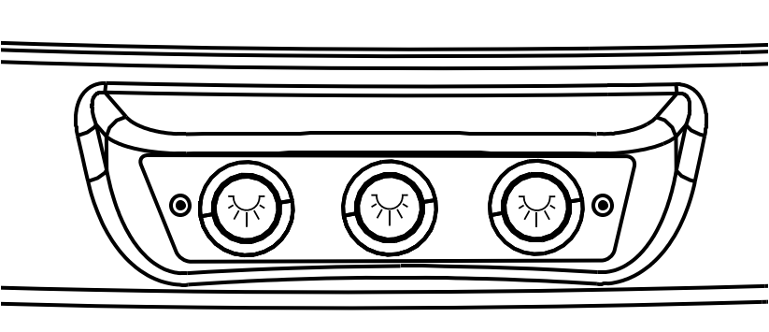
Figure 13. Cabin light switches

- Left switch – LED light on the left side
- Right switch – LED light on the right side
- Middle switch – toilet light switch. To turn on the toilet light on the back wall, touch it with your finger.

  - Correct use – other recommendations and instructions
    - Man overboard
Man overboard – situation is always serious. It is advisable to practise this in advance in good weather, as there will be no opportunity to do so in the event of an accident.

If someone falls overboard, always help them back into the boat from the stern. A rope loop attached to the boat makes lifting easier. The boat's swimming ladder extends about 55 cm below the water. If a child has fallen into the water, an adult must always jump in after them, taking extra life jackets or a flotation device with them, but someone must also remain in the boat.

It is very important to maintain eye contact and communication with the person who has fallen overboard.

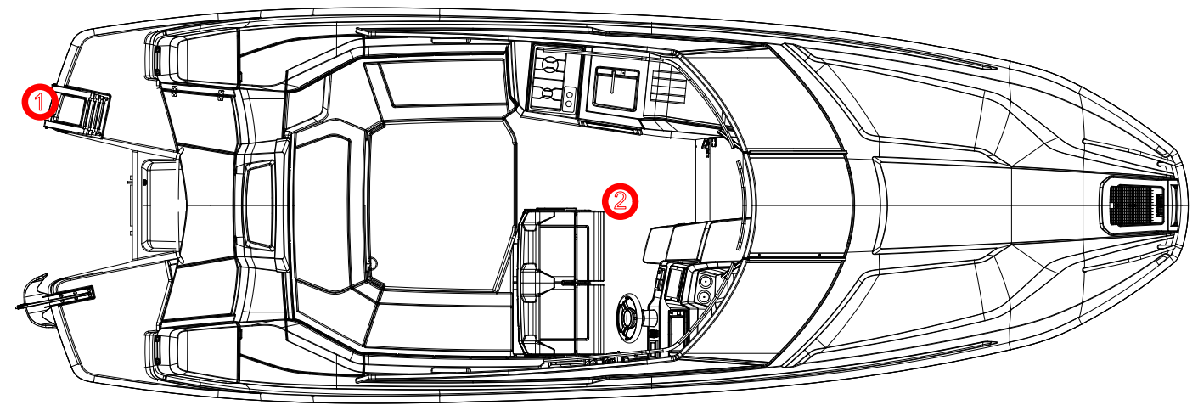

Figure 14. 1. Swimming ladder 2. Place for life raft

    - Storage of life raft
There is a place for the life raft under the deck, as shown in Figure 14. The maximum weight of the life raft is 28 kg.

DANGER! The rotating propeller is life-threatening to anyone who has fallen into the water or is swimming. Use the emergency stop switch and always turn off the engine when a swimmer or water skier boards the boat.

    - Securing loose equipment
Secure all heavy equipment, such as anchors, in place before departure.

    - Bow cabin sliding door

NOTE The cabin sliding door must be kept closed while driving.

    - Respect for the environment
The Finnish archipelago and lakes are unique, and preserving their natural environment is a matter of honour for boaters. Therefore, avoid

- fuel or oil spill
- disposing of rubbish or waste in the water or on the shore
- discharging detergents or solvents into the water
- loud noise both on the water and in harbours
- unnecessarily high wake, especially in narrow or shallow waters

Maintain your engine well and drive at an economical speed, which will also keep exhaust emissions low.

Everyone who spends time in nature is in Finland covered by the so-called everyman's right, which allows them to move around on other people's land without causing damage or disturbance, except in yards. This right also allows movement on waterways and temporary anchoring, swimming and landing on uninhabited shores, unless this is specifically prohibited by official regulations. Anchoring next to inhabited shores is prohibited. It is also prohibited to moor at another person's jetty or inhabited shore without permission.

Familiarise yourself with the international rules for the prevention of marine pollution (MARPOL) and respect them as much as possible.

You may camp on islands unless it causes damage to the landowner. Camping is prohibited near yards and farmland. You may only light a campfire with the landowner's permission. Boaters may also pick wild berries and mushrooms, as long as they do not damage trees or nature. Check the rules for outdoor activities in your area.

    - Use of toilets and septic tanks
The toilet uses sea or lake water for flushing. When flushed, the waste goes into the septic tank. The flush water shut-off valve is located under the maintenance hatch in the floor of the storage space on the left-hand side (BB) of the open space. In normal use, the valve can be kept open.

The toilet is flushed using an electric pump. The push button is located on the rear wall of the toilet.
The septic tank (= toilet waste tank) has a capacity of 30 litres and is located under the refrigerator. The suction drain cover complies with standard ISO 8099 and is located under the hatch of the rear anchor box on the left (BB) side.

NOTE! There is a latch at the bottom of the toilet door, which must be kept locked during driving.

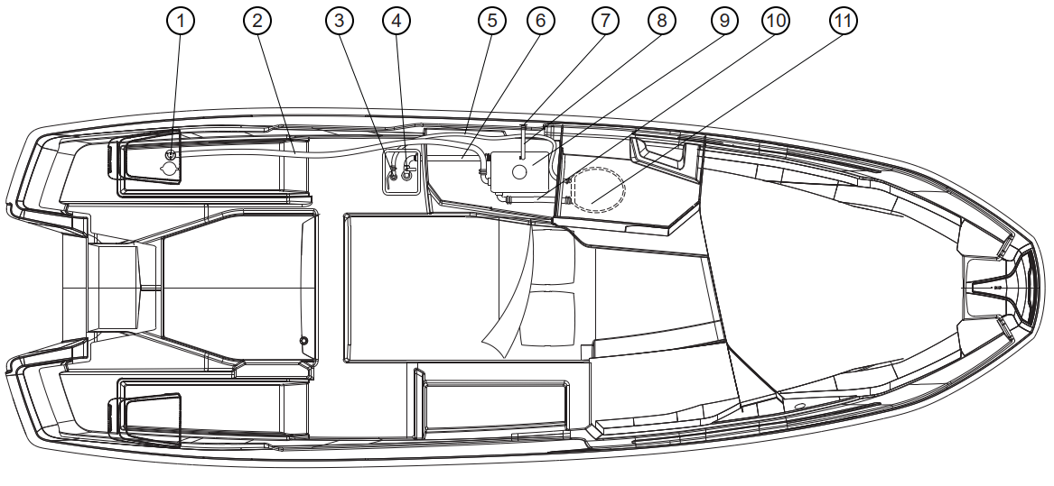
Figure 15. Septic tank system

1. Septic tank suction drain 7. Septic tank vent
2. Septic tank suction hose 8. Septic tank vent hose
3. Toilet flush water inlet pipe 9. Septic tank
4. Valve for emptying the septic tank into the sea 10. Hose from toilet seat to septic tank
5. Toilet flush water intake hose 11. Toilet seat
6. Hose for emptying the septic tank into the sea

The septic tank filling cap is marked WASTE, which means toilet waste.

Empty the septic tank at marinas using their suction equipment.

The valve for emptying the septic tank into the sea is located under the maintenance hatch at the bottom of the storage space on the left-hand side (BB) of the open space.
The septic tank sea discharge valve must be kept closed under normal circumstances, as the discharge of untreated toilet waste into the sea or lakes in Finnish territorial waters is prohibited under the Ship Waste Act.
Mildly alkaline general-purpose cleaning agents can be used to clean the septic tank and associated hoses, etc. Glycol can be used as an antifreeze agent. However, when stored in freezing conditions, the system should be as empty as possible.

    - Mooring and anchoring your boat
Always moor your boat carefully in a sheltered place, as conditions can change quickly. Mooring ropes should be equipped with shock absorbers to dampen jerks. See the mooring points in the section on towing. Use sufficiently large fenders to prevent chafing.

The forward strength of the bow cleats is at least 23 kN, or approximately 2,300 kg. Similarly, the backward strength of the stern cleats is 16.0 kN, or approximately 1,600 kg.

The boat must be equipped with an anchor weighing 7.5 kg or more. Lower the anchor far enough from the shore. Reasonable holding power is achieved when the rope is 4-5 times the depth of the water.

WARNING! Do not attempt to stop the boat with your hands, and do not place your hands or feet between the boat and the jetty, shore or another boat.

NOTE! When mooring your boat, take into account changes in wind direction, rising or falling water levels, stern waves, etc. Further instructions are available from insurance companies, among others.

    - Towing

When towing another boat, use a sufficiently strong, buoyant tow rope. Start towing carefully, avoid jerks, and do not overload the engine.

The boat owner must consider what measures are necessary to secure the boat's tow rope.

When towing or if your boat needs to be towed, attach the tow rope to the stern or bow bollards as shown in the picture.

WARNING! The tow rope is under high tension. If it breaks, the broken end may reach life-threatening speeds. Always use a rope that is thick enough and do not stand in the line of the rope.

NOTE When towing or being towed, always use low speed. If you are towing a displacement hull boat, never exceed the hull speed.

NOTE The tow rope must always be attached in such a way that it can be detached under load.

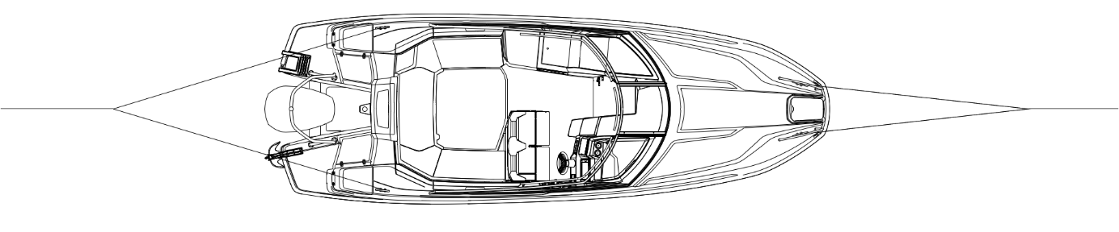

Figure 16. Attaching the tow rope to bollards

    - Trailer transport
Weight information for trailer transport can be found in the technical specifications. The trailer's keel supports should bear most of the boat's weight. Adjust the side supports so that the boat cannot sway sideways. If necessary, ask your dealer for more information on the correct support method and trailer size.

Clean any sand and dirt from the supports so that they do not scratch the bottom. Check once again that the trailer and the car's tow bar are securely locked!

The lifting site must be sheltered, and the trailer ramp must extend deep enough. Drive the trailer deeply that the rear keel support is just below the waterline. Carefully drive the bow of the boat onto the rear keel support. Attach the winch cable/rope to the towing eye and reel the boat onto the trailer, making sure that the boat remains straight and always centred on the trailer. To prevent the engine from hitting the bottom, remember to trim the engine up before lifting the boat onto the trailer.

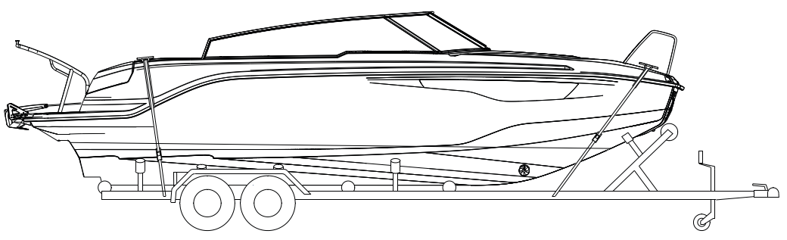

Figure 17. Securing the boat to the trailer

Secure the boat firmly to the trailer before starting transport. The bow straps should be oriented "down and back" and the stern straps "down and forward". Do not leave any loose items or excess load in the boat during transport. Remove the seat cushions and close all hatches securely.

The engine should be in the running position during transport. However, ensure that there is sufficient ground clearance. If there is insufficient ground clearance in this position, the engine can be transported in a tilted position. In this case, it must be supported with a suitable support device to protect the transom.

If the boat is stored on a trailer between transports, the straps must be loosened for storage and tightened before the next transport.

NOTE! The trailer should be slightly front-heavy. Ensure that the boat is securely fastened to the trailer and that the weight of the boat is evenly distributed on the side beams. If a swaying boat hits a single support during transport, the hull may be damaged.
When lowering the boat from the trailer, remember to attach the bow rope to the boat in advance so that you can remove the trailer cable/strap from the towing eye as soon as the boat is in the water. Beware of the winch handle!

    - Docking
The winter storage cradle must be strong enough for the specific boat/engine combination. A strong plank (e.g. 2x4") should be placed between the V-blocks to support the keel and bear most of the boat's weight. The side supports must not bear the weight of the boat. The side supports must not touch the corners at the bottom and point loads must be avoided. The support structure must be strong, especially near the transom, so that it can also bear the weight of the engine.

Only entrust the lifting to a reliable crane company or boat yard with sufficient lifting capacity. In addition to the boat's own weight (see technical specifications), take into account the equipment and other loads on the boat.

When lifting the boat, place slings under the bottom and ensure that the boat remains horizontal during lifting.

NOTE! The boat must not be lifted by its keel.

DANGER! Do not go under the boat when it is suspended from the crane.

- Maintenance of the boat and equipment
Keep your boat and its equipment clean and tidy. This increases comfort and safety as well as the resale value of the boat.

Familiarise yourself with the maintenance procedures described in the engine manual.
Service your engine according to the engine manual.

  - Washing and waxing the boat
Washing and waxing is usually sufficient for maintaining the deck and sides. Special boat cleaning agents are best suited for washing. Use mild cleaning agents. Do not use strong solvents (pH value must not exceed 11), as they may dull the shine of reinforced plastic surfaces. You can use mildly abrasive polishing agents to remove scuffs or stubborn dirt. Fibreglass surfaces can be washed with a pressure washer.

General tip: When washed with tap water, a thin, chalky layer of limescale and minerals remains on the boat after it dries, due to the hardness of the water. This can be removed by adding a few drops of pine soap solution to a bucket of rinse water.

General tip: If your boat ropes smell bad after the season, soak them for a couple of hours in a bucket of water with a bottle of apple cider vinegar and a dash of fabric softener. Let them dry thoroughly and they will be like new.

  - Care instructions for seat cushions
Always protect the open area of the boat and the cushions in the open area from rain with a canopy or harbour cover. Even though the seat cushions and driver's seat are made of water-resistant material, their seams allow water to pass through. If the cushions remain damp for a long time, they will become mouldy and ruined. If the cushions get wet, the fabric can be removed by opening the zip on the cushion and dried, for example, in the sun, at room temperature or in a sauna (50 °C). The warranty does not cover seat cushions that have been damaged by rain or moisture.

NOTE! To keep the boat's seat cushions in good condition over the winter, they should be stored in a dry and well-ventilated area.

NOTE! Wet cushions should not be placed in storage areas, as they will mould easily.

The seat cushion stud buttons should be treated with silicone Vaseline from time to time, otherwise they may stick so tightly that the fabric may tear when removing them. The warranty does not cover damaged seat cushions. Apply a very small amount of silicone Vaseline at a time to prevent the cushions from becoming sticky.

  - Care instructions for the canopy
Store the canopy in a dry and well-ventilated place over the winter. The warranty does not cover damaged or mouldy canopies.

  - Windscreen care instructions
The boat's windscreen is made of tempered glass and can be cleaned with normal glass cleaning agents.

  - Care instructions for acid-resistant parts
To keep the boat's acid-resistant parts, such as railings, handles and bollards, bright and like new, the boat owner must keep the parts clean and waxed. The edges of the handrail mounting flanges should also be cleaned. Dirt that remains under the edge of the flange will gradually start to look like rust. If there is no damage, the parts should be cleaned and waxed at least twice during the summer. Handrail maintenance should also be carried out in the autumn when the boat is moved to winter storage.

General tip: Water spots and limescale stains can be removed from acid-resistant railings with Lemon Pled furniture spray or by treating them with half a lemon.

  - Care instructions for the electronic remote control
If you experience problems with the operation of the electronic remote-control device, have it serviced immediately by an authorised service centre.

  - Care instructions for the steering system
Hydraulic steering does not normally require maintenance. If the steering becomes "loose", there is a leak in the system. The leak must be repaired immediately!

WARNING! A hydraulic steering system with a leak or air in it is life-threatening.

  - Care instructions for electrical components
Electrical components such as main circuit breakers, all other circuit breakers and connectors do not normally require maintenance if the boat is stored in a dry and well-ventilated place during the winter. However, if you want to protect the boat's electrical components against oxidation, the best way to do this is to spray them with a moisture and corrosion inhibitor.

  - Minor surface repairs
You can repair minor surface damage to the hull or deck yourself. However, achieving a neat and inconspicuous result requires skill:

- Protect the area around the repair with tape.
- Sand the edges of the dent to a bevel and clean with acetone.
- If the damage is more than 2 mm deep, fill it with filler before painting.
- Mix 1.5-2% hardener into the topcoat.
- Apply the topcoat to the area to be repaired so that the surface is slightly higher than the surrounding surface.
- Carefully place tape over the repair.
- Once the topcoat has hardened, remove the tape and, if necessary, sand the repair area smooth with 600 and 1200 grit wet sandpaper.
- Polish the repair with polishing compound and wax.

The colours used on the boat are listed in the technical specifications. It is good to know that a paint called gelcoat is used in the manufacture of the boat, but afterwards the surface is always repaired with a paint called topcoat. Gelcoat paint does not harden without a mould surface, but paraffin has been added to the topcoat to enable hardening.
NOTE! Certain retrofits and modifications, if done incorrectly, can damage the boat's structure or pose a safety hazard. Contact your dealer if you are planning to make any modifications to the boat.
- Winter storage of the boat
Preparing your boat for winter is an annual routine. Lift your boat out of the water well before the ice sets in. Your boat is not designed for use in ice and is not intended for use in temperatures below 0 °C (e.g. the rainwater drainage system will freeze). When winterising your boat, it is a good idea to go through all maintenance, repair and inspection tasks.

Refer to the maintenance procedures in the engine manual. We recommend that you have this work carried out by an authorised service centre. Also remember to service the remote control and steering system. Carry out this maintenance in accordance with the separate instructions and manuals.

  - Measures to be taken before winter storage
Wash the bottom of the boat immediately after hauling it out of the water. Algae and slime are easiest to remove before they dry. Drain the cooling water from the engine according to the manual.
Perform winter maintenance on the engine and other equipment in accordance with the separate manuals. If you store your boat outdoors or in damp conditions over the winter, remove any textiles and other equipment that may become mouldy or otherwise damaged by moisture. Wash the ropes in fresh water. Replace worn ropes. Leave the through-hull valves open. Remove and leave the drain plug loose for the winter.

Empty the boat's septic tank and freshwater tank. Pour 2 litres of a 50% glycol/50% water mixture into the toilet bowl and press the flush button for about 2 seconds.

Check the condition of the hull and sand down any dents so that any moisture that may have penetrated the laminate can dry out. Repair any damage in the spring before launching the boat.

Remove all food from the boat and wipe all surfaces where food has been handled with a disinfectant. This will prevent mould from forming.

Cover your boat so that snow cannot accumulate inside it. However, always ensure adequate ventilation. A winter cover for your boat is available as an accessory.

  - Measures to take before launching in the spring
Repair or have repaired any dents in the gelcoat in accordance with section 6.

In marine areas, prevent vegetation from attaching to the hull by applying antifouling paint. Fouling of the hull and especially the propeller significantly increases fuel consumption. When painting, carefully follow the paint manufacturer's instructions. If you are sanding off old toxic paint, remember that the resulting sanding dust or slurry is toxic.

Antifouling paint is not necessary in lake areas. However, we recommend using an epoxy primer if the boat is in the water for several months each year. Fresh water, especially warm fresh water, is more easily absorbed into laminate than sea water.

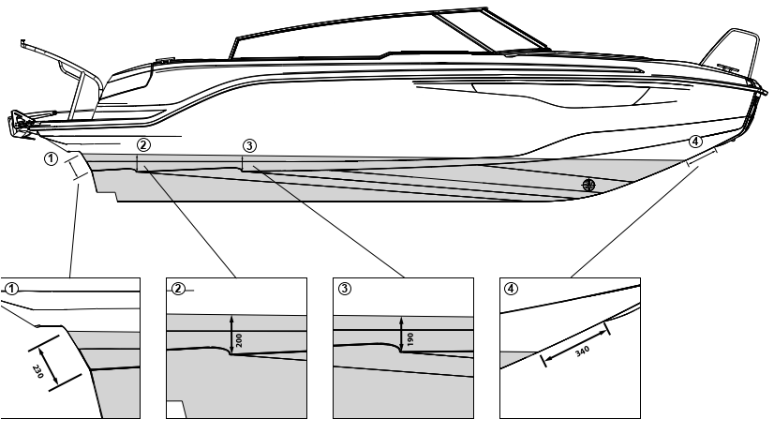
Figure 18. Upper line of antifouling paint

NOTE! Do not paint zinc anodes or the piston rods of the engine spark hydraulic cylinders. Do not use copper-containing paints on aluminium parts. Follow the paint manufacturer's instructions.

General tip: Do not throw away used paint brushes. Hardened antifouling paint brushes can be restored by soaking them for a couple of hours in a mixture of two litres of hot water, one decilitre of vinegar and half a decilitre of baking powder.

Perform the maintenance required by the engine in accordance with the engine manual. Check the operation of electrical equipment and remove oxidation from fuse connections and other connections.

Remember that petrol expires, so always start with fresh petrol in the spring.

After launching the boat, open all the through-hull valves and check that there are no leaks in the hoses or connectors. The location of the through-hulls is shown in chapter 5.

- Layout

  - General layout

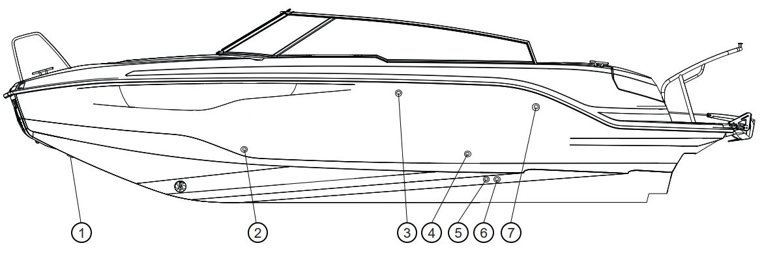

Figure 19. Through-hull fittings on the port side

1. Bow anchor box drain 5. Septic tank sea drain
2. Toilet washbasin and sink 3. Septic tank vent
3. Septic tank vent 6. Toilet flush water inlet
4. Gas cylinder compartment ventilation 7. Heater exhaust gas feed-through
pass-through

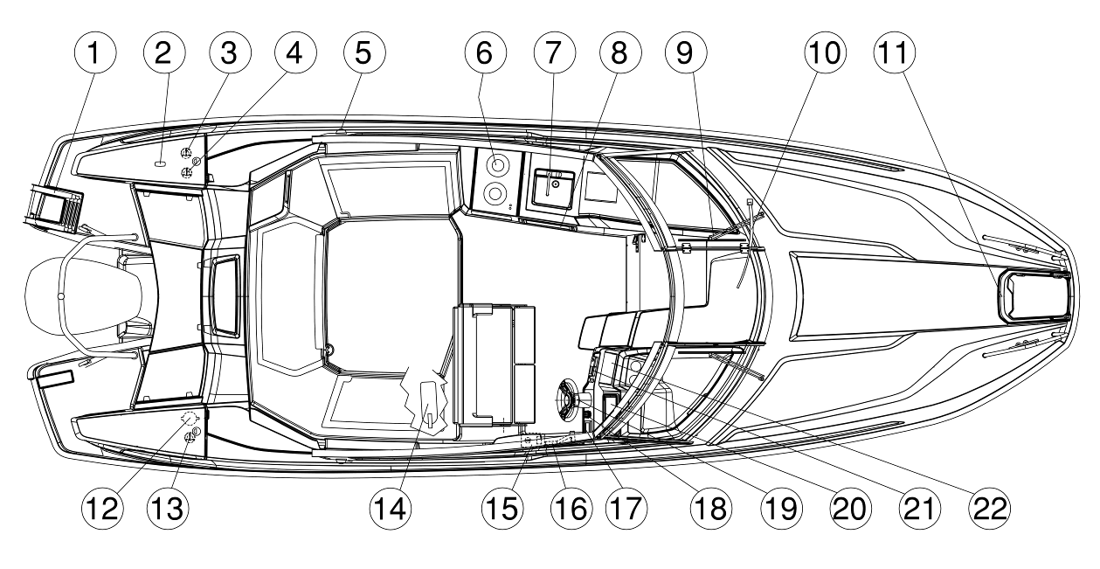

Figure 20. General layout from above

1. Telescopic swimming ladder 12. Swimming platform shower
2. Light mast base 13. Fuel filler cap
3. Septic tank suction drain 14. Fire extinguisher
4. Fresh water tank filler 15. Trim control panel
5. Navigation lights 16. Electric remote control
6. Gas stove 17. Engine gauge
7. Fresh water tap / sink 18. Remote control for bow thruster
8. Refrigerator 19. Steering wheel
9. Windscreen wiper 20. Chart plotter
10. Windscreen door pump 21. Radio
11. Landing steps 22. Glove compartment / tablet holder

The septic tank filling hose is marked WASTE, which means toilet wastewater.
The water tank filler cap is marked WATER, which means fresh water.
The fuel tank cap is marked GAS, PETROL or FUEL, which means petrol 95E or 98E.

WARNING! Handle the boat's hatches with care and avoid getting your fingers or toes caught between them.

WARNING! The use of the bow anchor box hatch is not recommended for children, as their fingers or toes may get caught.

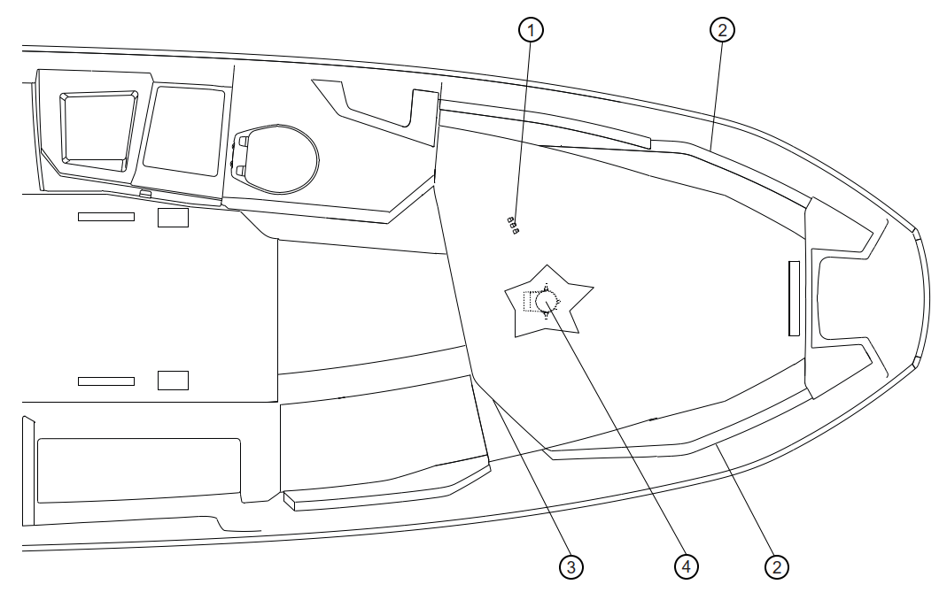
Figure 21. Cabin layout

1. Cabin light switches 3. Bed storage space
2. Cabin side lights 4. Bow thruster (under the berth)

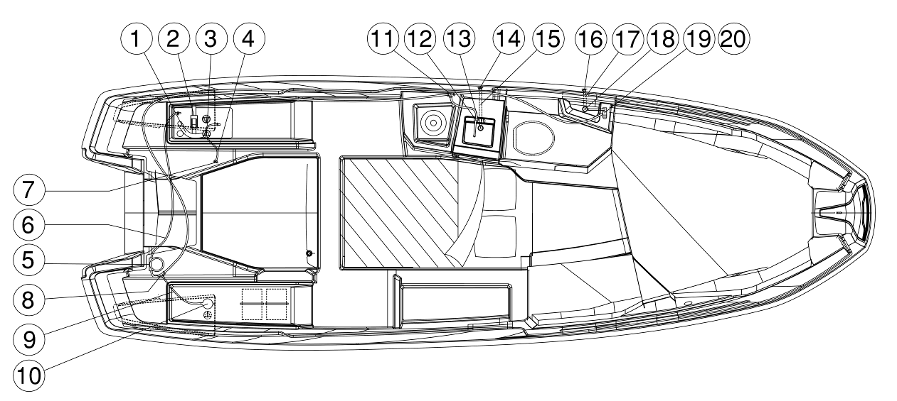

Figure 22. Fresh water system

1. Water tank filling hose 11. Water hose connector for toilet tap
2. 45-litre water tank 12. Water tap
3. Water tank filling valve 13. Washbasin bottom drain
4. Water tank vent hose 14. Washbasin drain
5. Pressure water pump 15. Washbasin drain hose
6. Water hose from water tank to pressure 16. Toilet washbasin outlet
water pump 17. Toilet washbasins drain hose
7. Water tank vent pipe 18. Bottom outlet for toilet washbasin
8. Water hose branch piece for shower 19. Toilet washbasins tap
9. Shower water hose 20. Washbasin
10. Swimming pool shower

The water tank filler cap is marked WATER, which means fresh water.

  - Fuel system
The boat is equipped with a fixed fuel tank. A fuel filter is installed in the fuel line, which also acts as a water separator. The filter must be replaced at least once a year. Once a new filter or a filter that has been removed has been installed, the fuel line must be pumped full with a ball pump before starting the engine.

NOTE The condition of the fuel hoses must be checked at regular intervals and damage to them must be prevented. Defective fuel hoses must be replaced. If you replace the fuel hoses, make sure that they are marked ISO 7840.

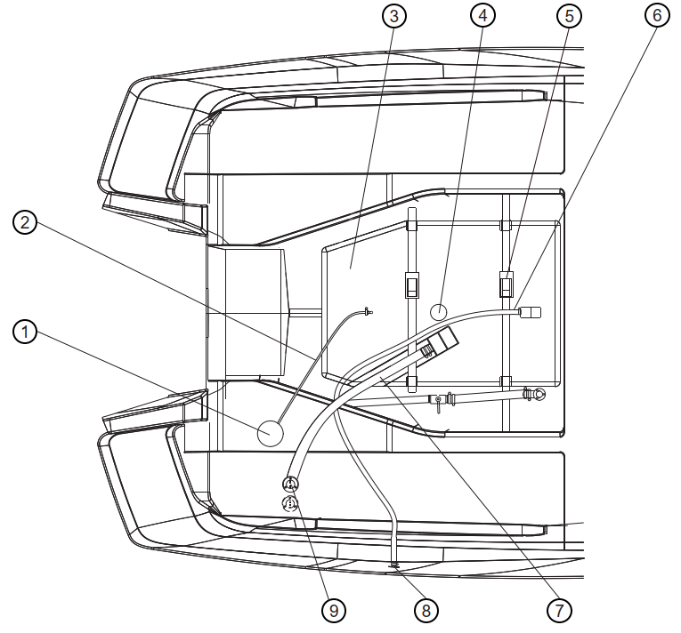
Figure 23. Fuel system

1. Fuel filter (BB in rear anchor box) 6. Fuel tank vent hose
2. Fuel tank supply hose 7. Fuel tank filler hose
3. Fuel tank 8. Fuel tank vent cap
4. Fuel tank sensor 9. Fuel filler cap
5. Fuel tank fastening strap

The fuel tank filler cap is marked with the symbol " " on the boat's deck.
The fuel tank cap is marked FUEL, which means petrol 95E or 98E.

  - Steering system
The boat is equipped with hydraulic steering. One of the features of the hydraulic steering system is that the position of the steering wheel changes continuously, which is why the boat has a symmetrical steering wheel. The lengths of the hydraulic hoses are:

- 2 x 3.6 m
- 2 x 2.6 m

Hydraulic steering does not normally require maintenance. If the steering becomes "loose", there is a leak in the system. The leak must be repaired immediately!

NOTE! If you replace any component in the steering system, you must ensure that all components comply with the requirements of ISO 10592 and are CE marked.

WARNING! A hydraulic steering system with a leak or air in it is life-threatening.

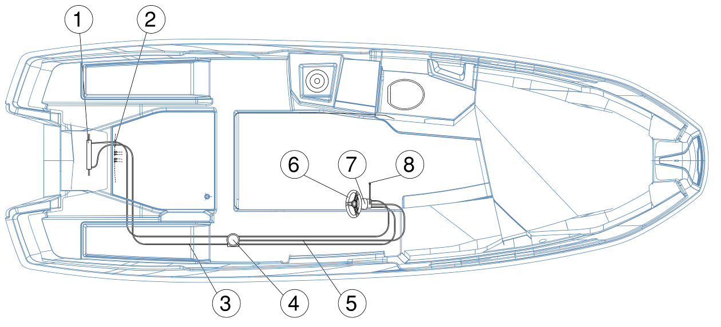
Figure 24. Steering system

1. Hydraulic steering cylinder 5. Oil overflow pipe
2. Hydraulic hose feed-through 6. Steering wheel
3. Hydraulic hose 7. Tilt control pump
4. Power steering (optional) 8. Hydraulic steering oil filling

  - Electrical system
The electrical system consists of the following main components:

- Starter battery
- Service battery
- Wiring harness
- 2 main power switches
- Battery compartment fuse panel
- 8 circuit breakers
- 2 x 12V outputs
- 5 USB outputs
- Running lights
- Deck lights
- Driving/search lights
- Windscreen wipers (right and left side)
- Pressure water pump
- Toilet seat
- Toilet light
- Defroster
- Cabin lights + switches
- Refrigerator
- Mente Marine trim system
- Radio
- Bow thruster

In addition, the boat's electrical system also includes the engine, which acts as both a power source and a consumer.

When disconnecting or connecting batteries, be careful not to touch both terminals of the battery with a metal object at the same time.

Do not modify the boat's electrical system or related drawings; modifications and maintenance should be left to a professional.

Solar panels for the bow deck are available as an accessory for the boat.

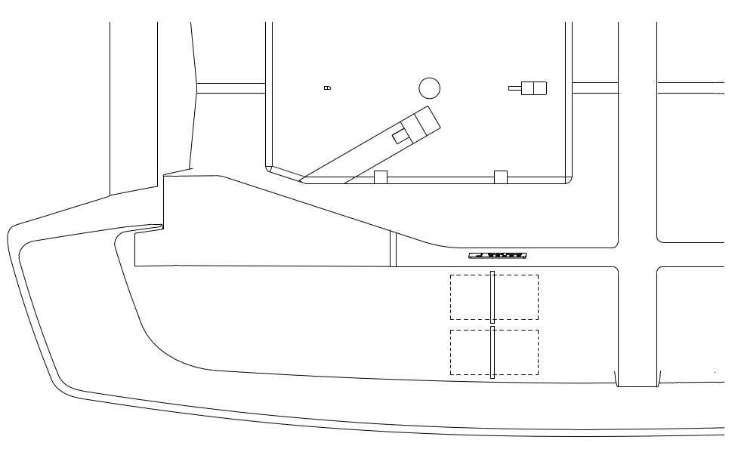

Figure 25. Electrical system

1. Battery (starting and service battery) 3. Bow thruster fuse
2. Main circuit breakers and fuse panel 4. Stern anchor winch fuse

  - Wiring diagram
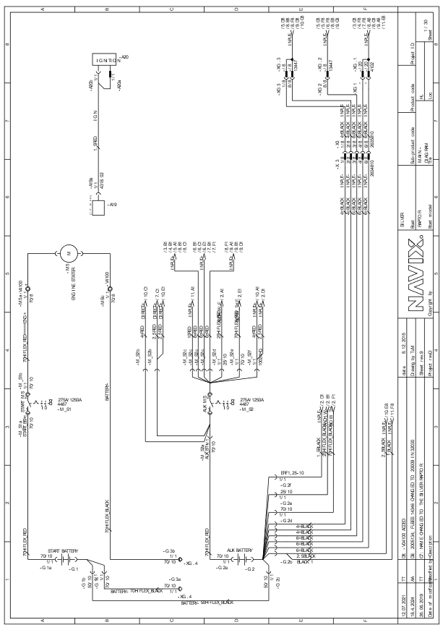
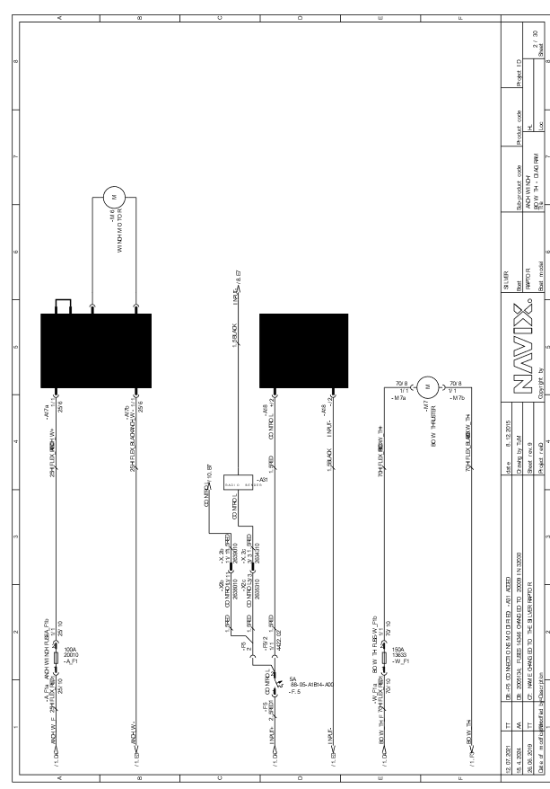

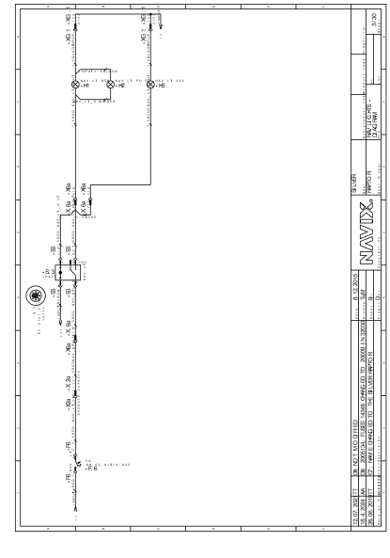
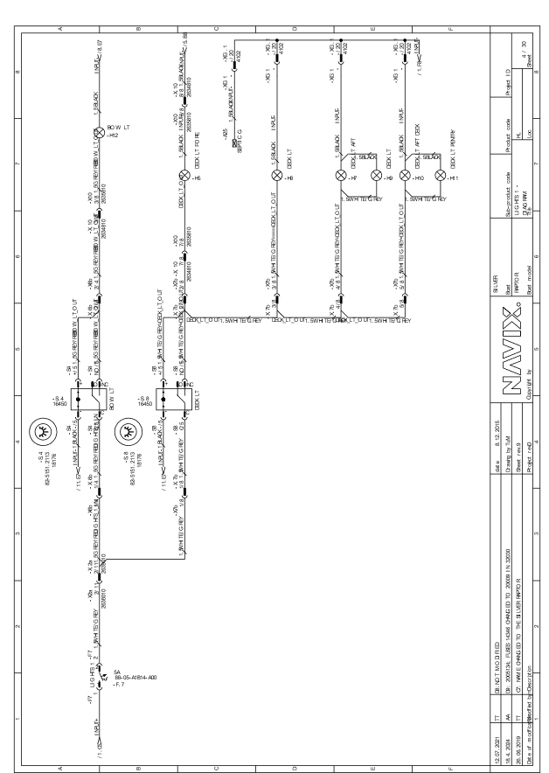

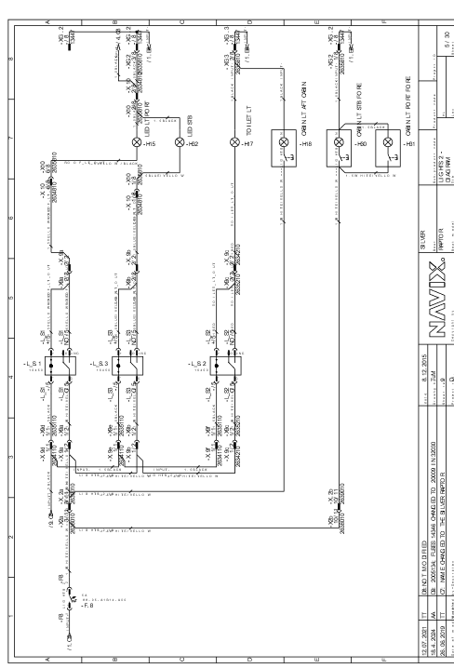
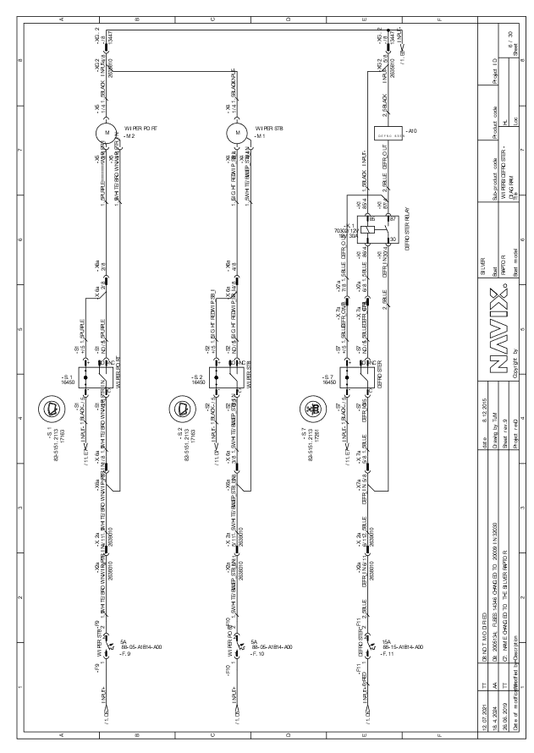

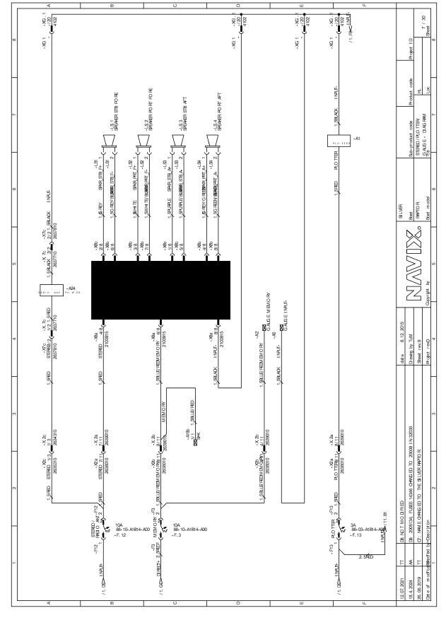
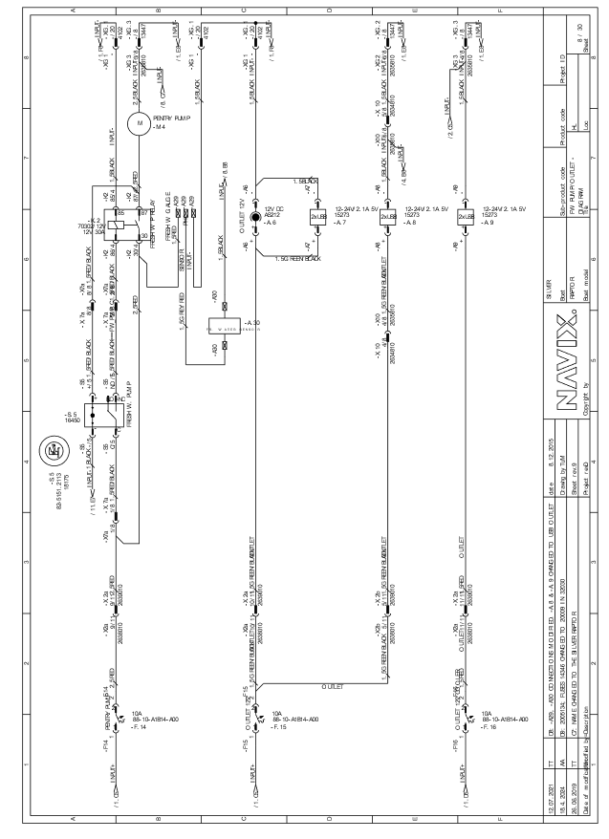

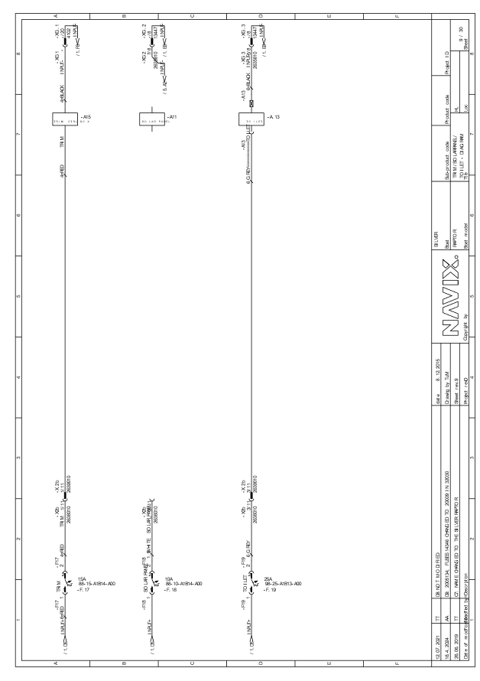

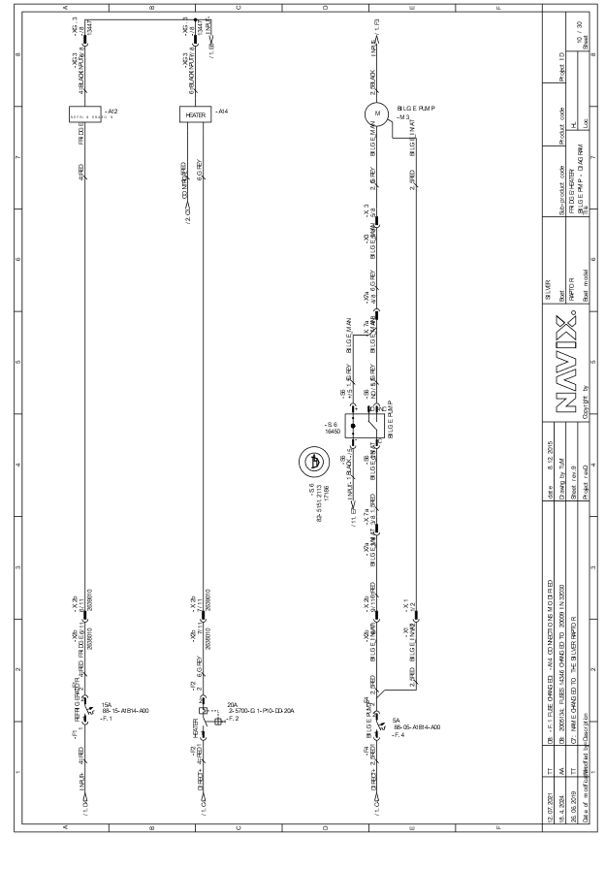
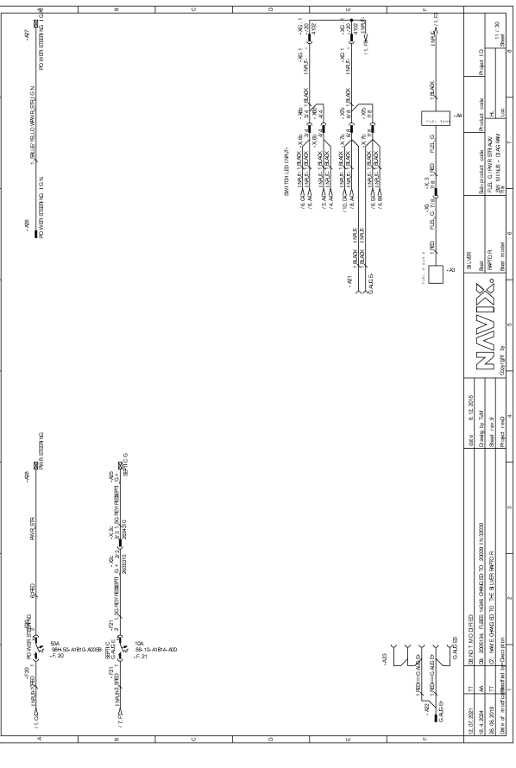

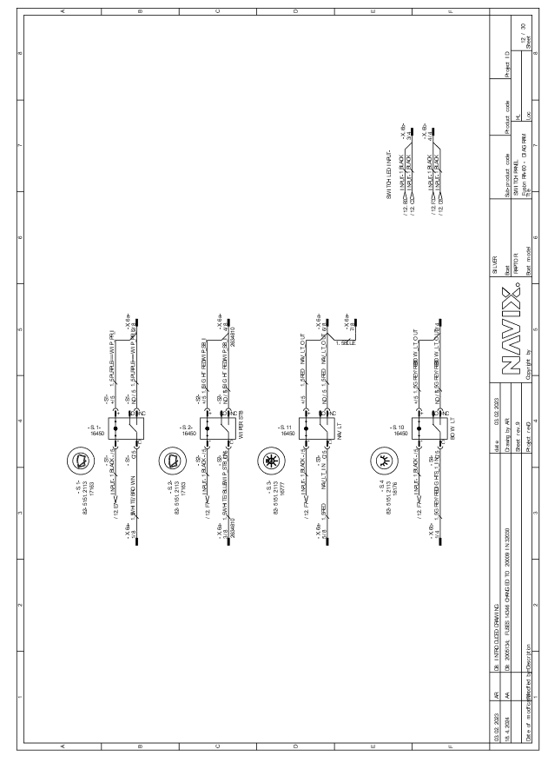
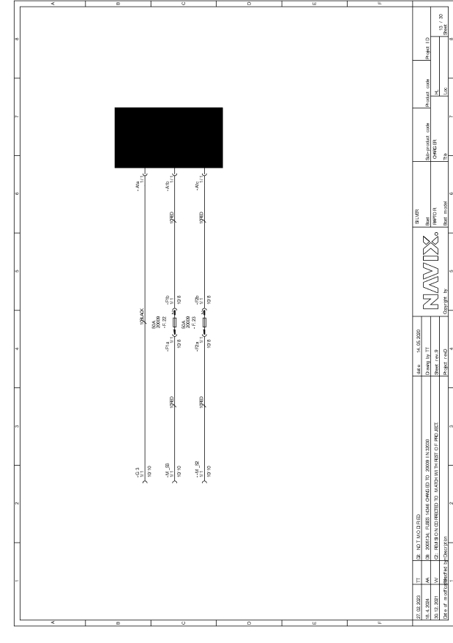

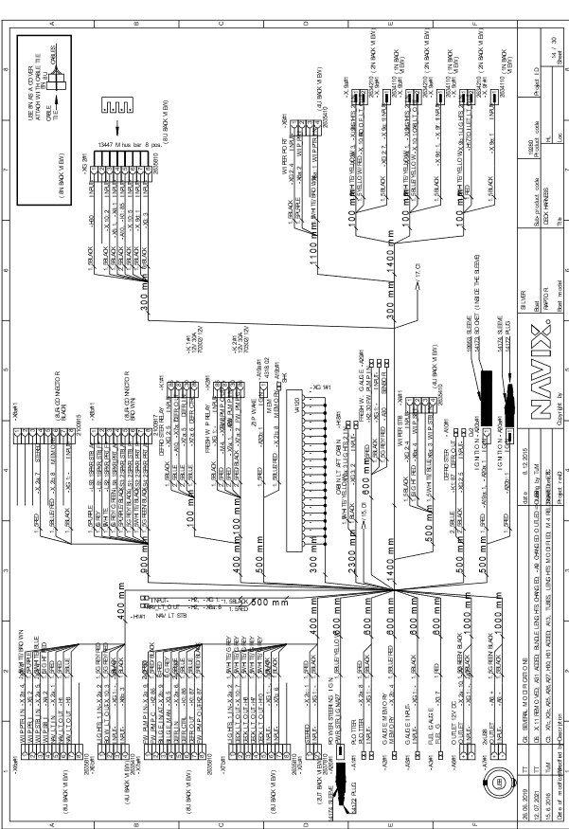
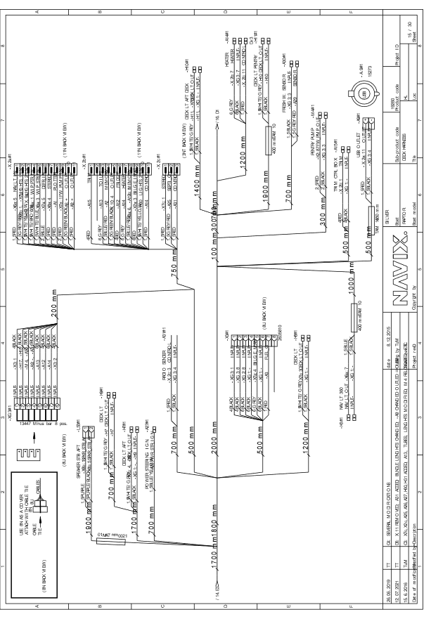
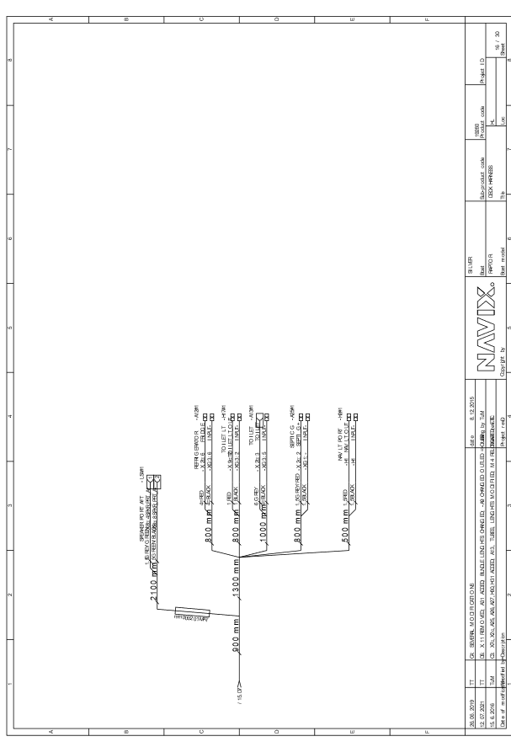
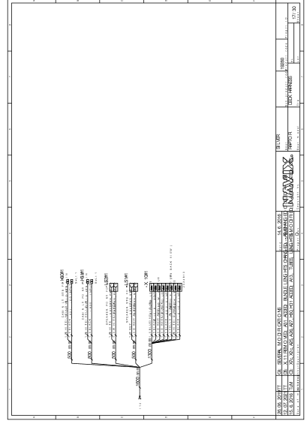
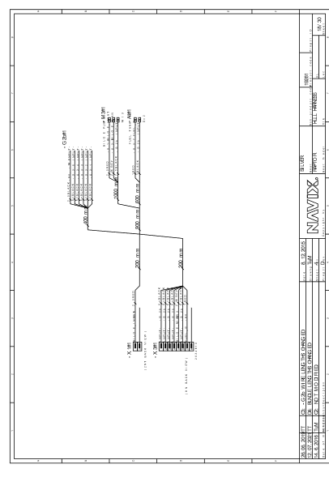
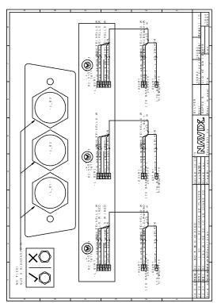

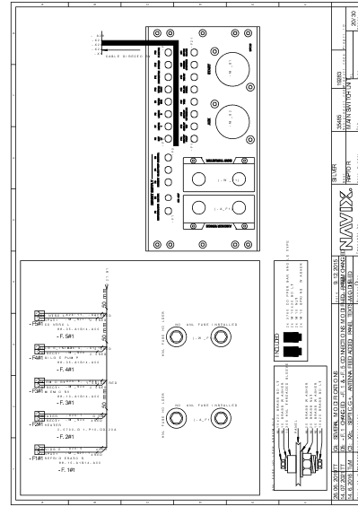
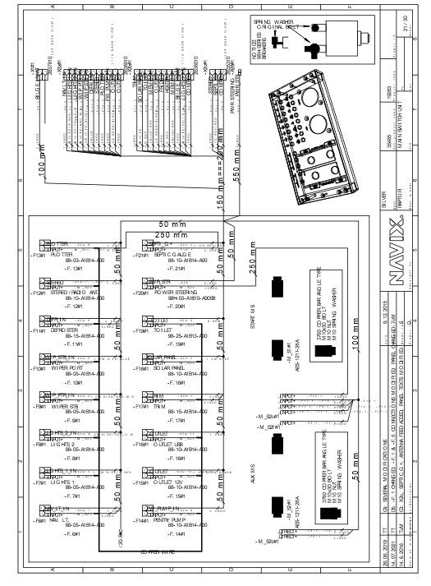

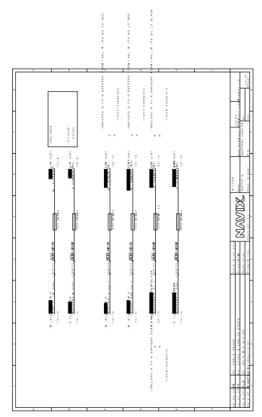
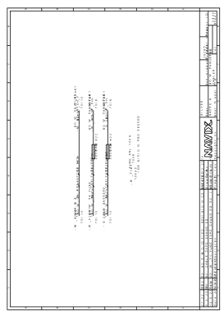

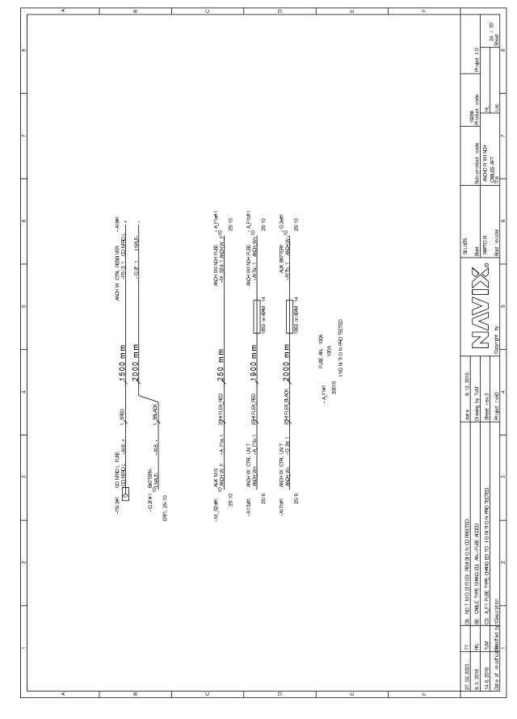
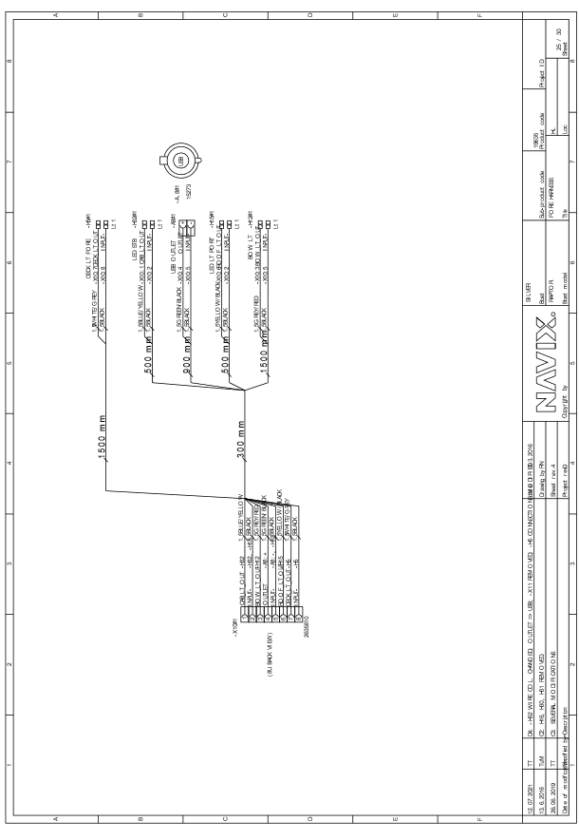

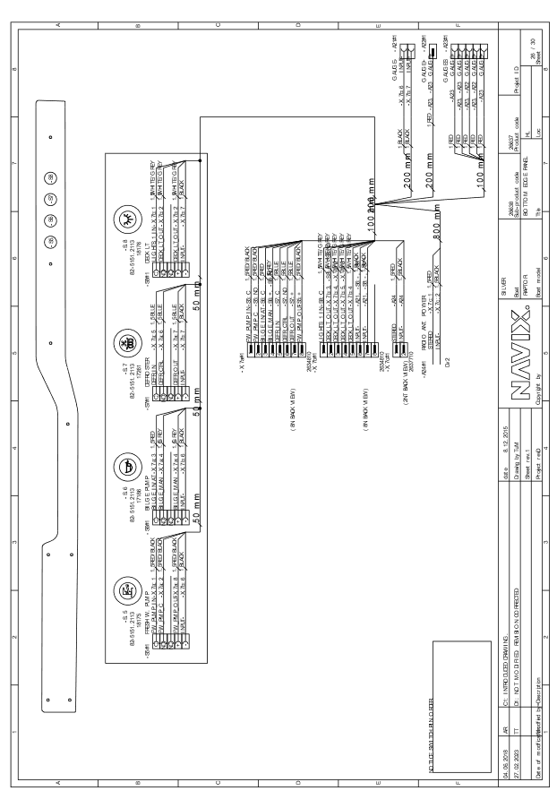

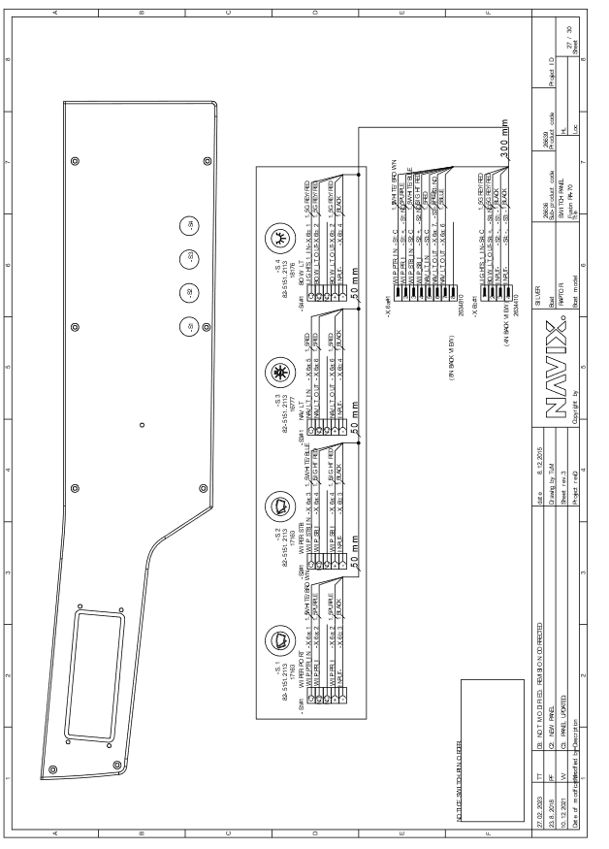

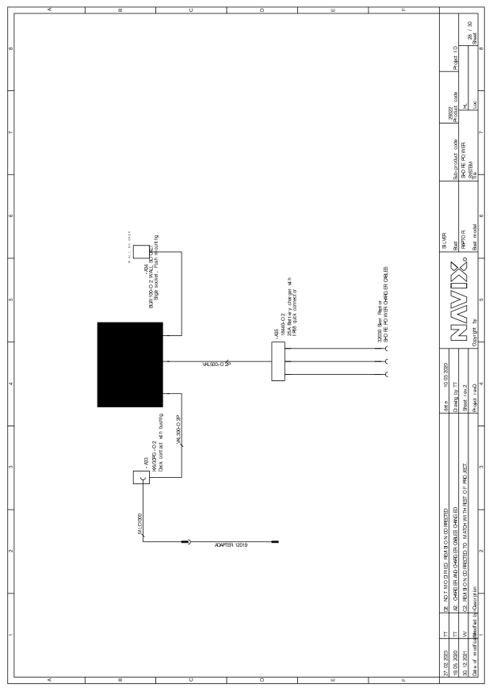

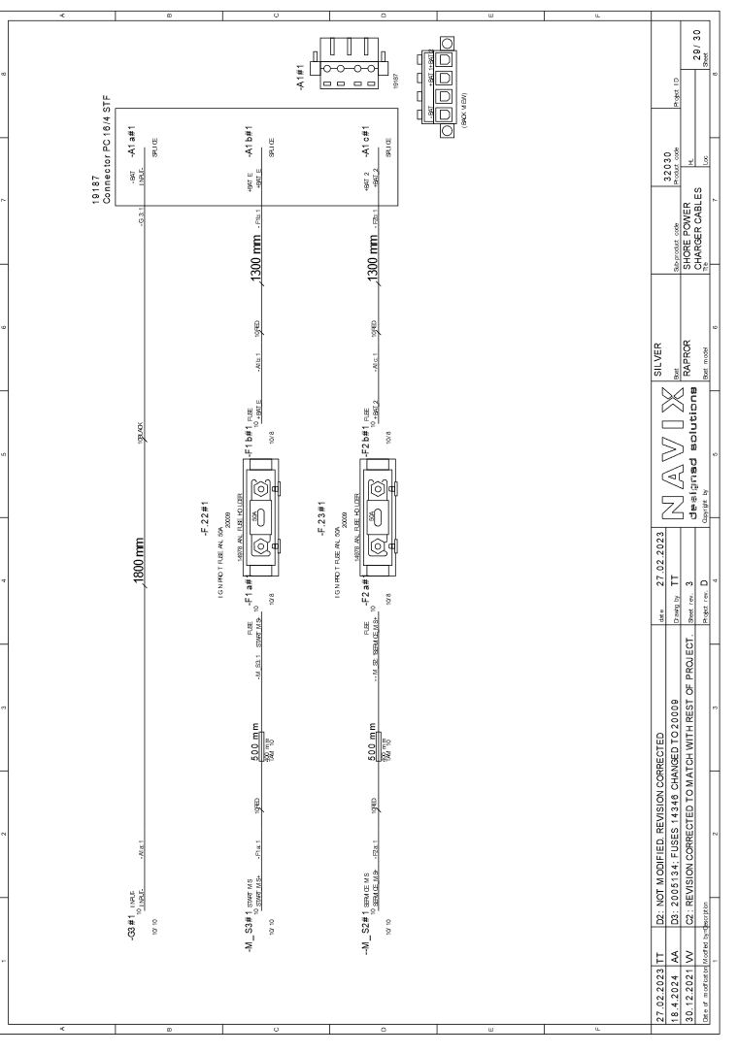

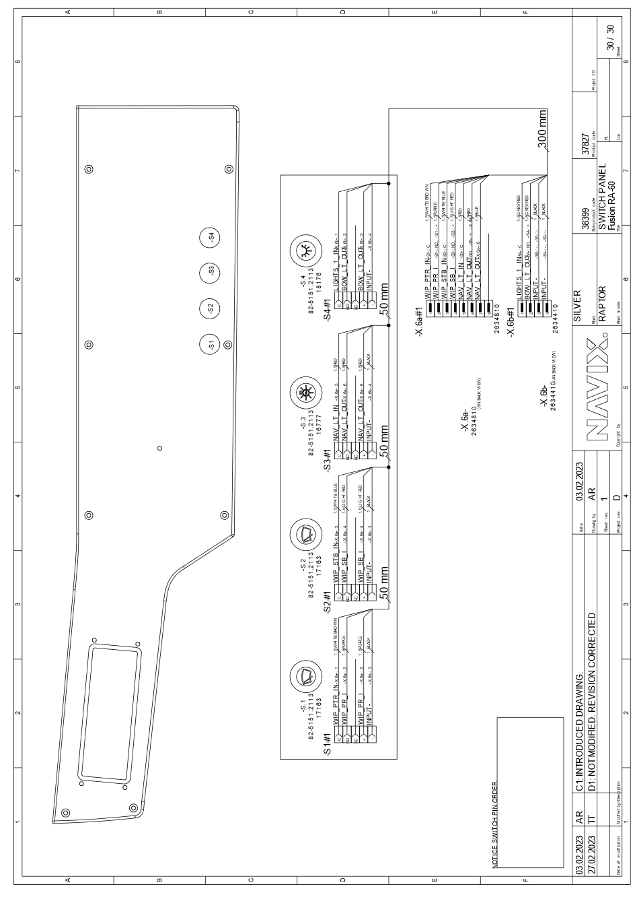

Non-harmonised standards, rules, regulations, guidelines, etc.
Standards published in the Official Journal of the European Union
See the engine manufacturer's declaration of conformity
Applies only to boats with inboard or stern drive engines without a built-in exhaust system

